**eExcel Analysis**

* Excel analysis is the process of using microsoft excel and a spreadsheet to analyze, study and understand the data.
* It involves tasks like organizing data into the tables, making charts and finding data in the table.

1. **“Home” tab :**  Home tab is located in the ribbon interface at the top of the excel window. It's where we can do things like changing the look of text, cutting, copying, and pasting information, adjusting cells, adding or removing columns and rows.
2. “**Insert” tab:** We can put in tables to organize the data,picture,shapes, and charts to show the information.We can also add filters to easily sort our data. We can also add hyperlink and textbox.
3. **“Page Layout '':** Page Layout tab helps us to make our spreadsheet neat and nice for printing. We can choose a theme for our spreadsheet and also choose a picture for our spreadsheet background,adjust the page,resize it.We can also customize things like headers,gridlines,and footers.
4. **“Formulas' ':** In the formulas tab where we can go to math and calculations. It has tools for using different types of functions, like adding numbers,finding averages or counting things,and we can manage names, checks for errors in our formulas.
5. **“Data”:** In data tab we can get and transform data from others places like, files, database, from text, web,sort data alphabetically or numerically also apply filter to search only specific data, tools for removing duplicates data ,data validation, create outlines to group and organize data in our spreadsheet.
6. **“Review”:** In the review tab of excel we will find the tools for reviewing our spreadsheet, we can check spelling, grammar and access the thesaurus for word suggestions,smart lookup is use to search for definitions and images, translate the text into different languages, we can add,edit,show and hides the comments within our spreadsheet,protect our spreadsheet and workbook with a password.
7. **“ View”:** The view tab in excel allows us to switch between different views , like page break view, page layout, and we can also show and hide the headings, gridlines and formula bar, zoom in or out and manage multiple open workbooks and switch workbooks.
8. **“Help”:** Help tab provides detailed information and instructions on how to use excel features and tools. Get help and support from an office. We can give feedback if there is something they do better.
9. **“Tell Me What You Want To Do”:** In this we can type commands we want to perform and excel provides relevant results.
10. **“File”:** In the file tab we create a new worksheet and any template. Open an existing workbook from our computer. save our current worksheet. share our worksheet with others.we save our worksheet in a different file format such as pdf.

* we can start entering data from anywhere for data entry. It is not necessary that we start from ‘A’ block.If we want we can start from the center.
* On the top if we want to give any heading like our monthly expenses. Then I give “January month expenses”.
* If I want to increase its size then I can increase its width . I want to give any color then we can give color for color. I can select the specific cell then go to the home tab and we can see the paint option whatever color we want to give here we can pass that. Also we can change the text color
* we can increase the cell size. We want to merge it into different cells then we can select the cell and we get the merge center in the home tab.we can click on the merge in the center.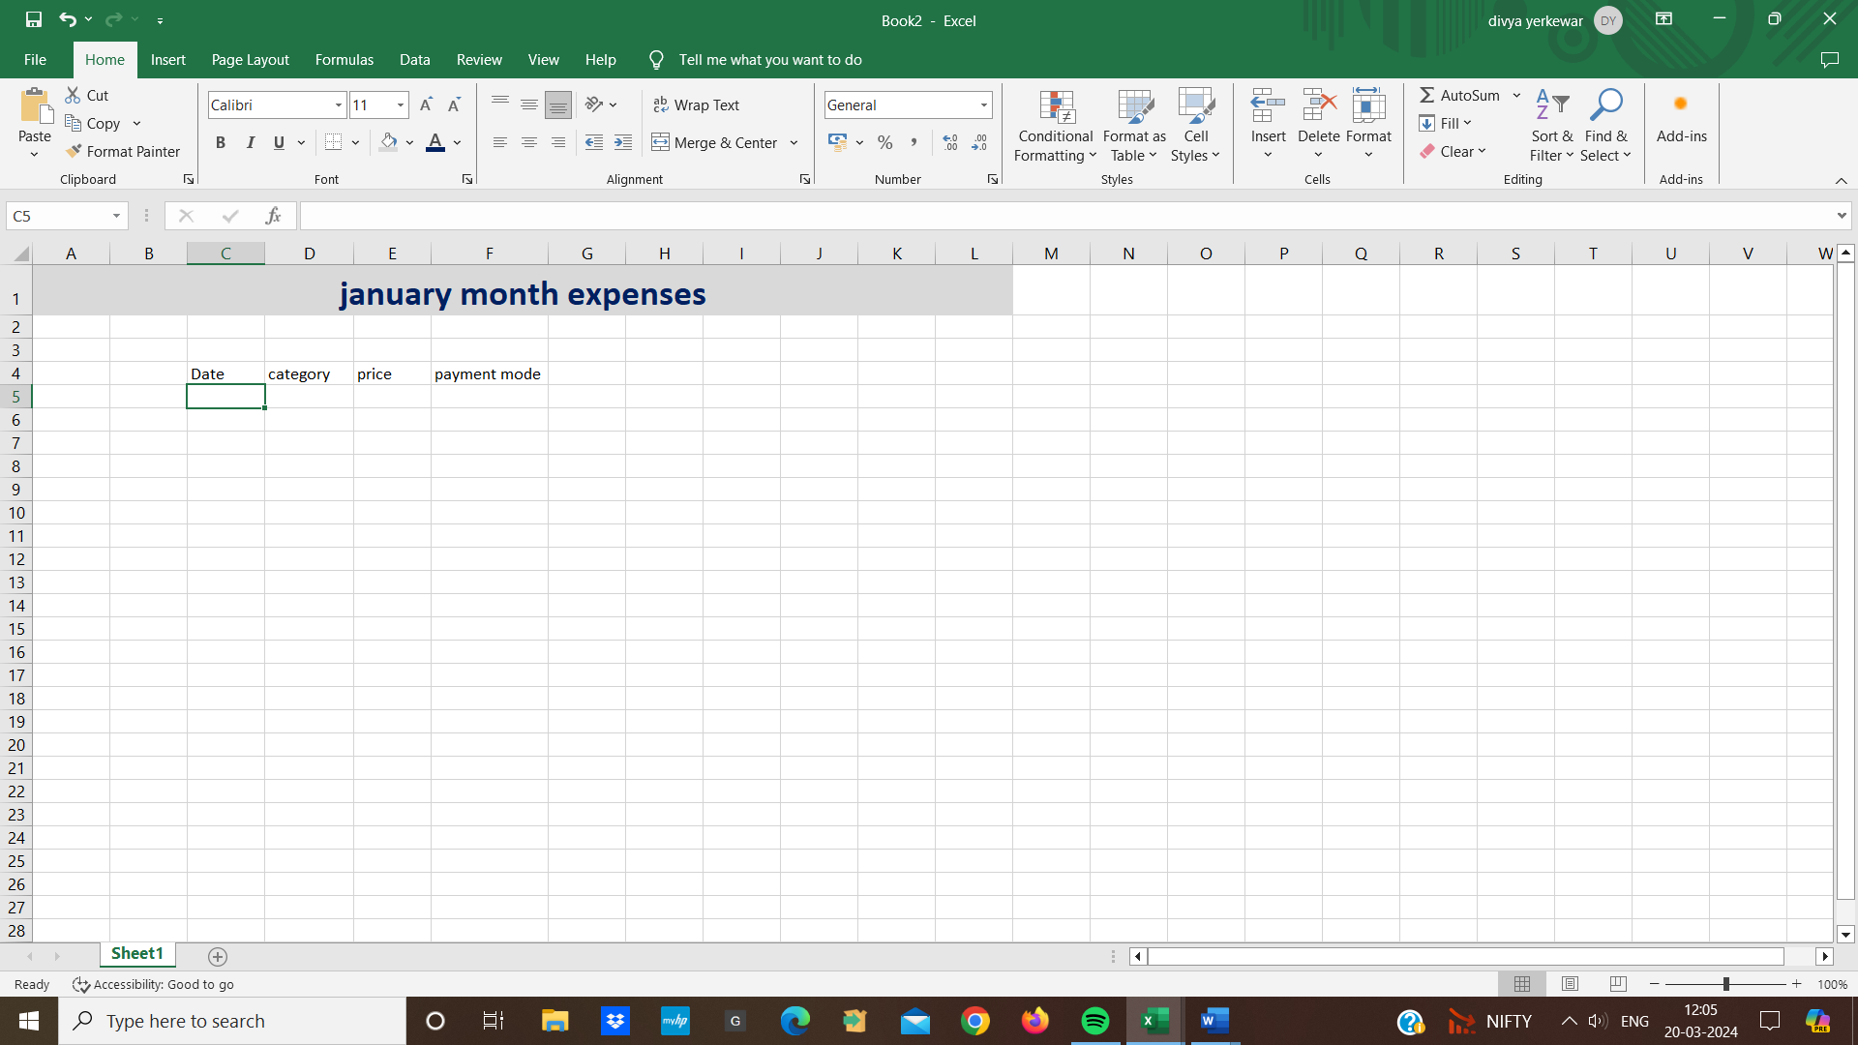
* we want to increase the text size on the top we will get the text size
* Then we create a sheet we will first start will headings
* First we take the date, after the date we move to the next cell and take the category I spent , i have to give a subcategory ,how much did i price it so i can take price and last we take payment mode.

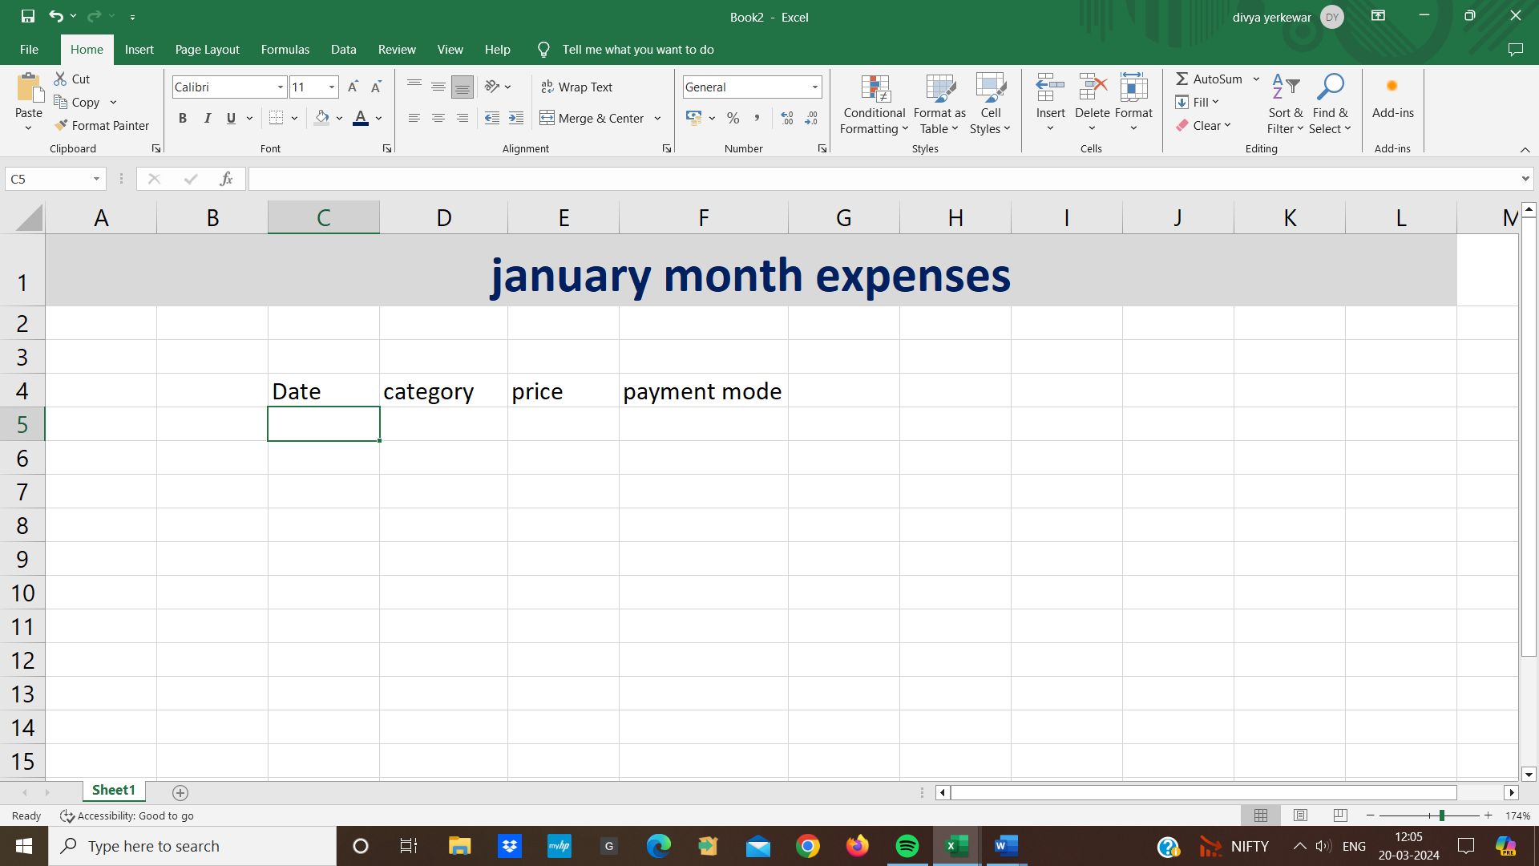

* we notice that subcategory, payment is not able to take up the space completely.In that case i will go the top of the cell and double click
* I stared from date 1st january ,we mention category such as food, i ordered from zomato so i mention zomato in sub-category, i paid the price 300 and my payment mode was UPI
* we will notice that the numbers are aligned towards the right in the number category
* we can change the alignment we can pick any cell we want to center alignment we can choose the center
* if we cannot understand the headers or table data then we select the headers row and edit the text size if i want to keep it bolds then i can
* similarly we can start inserting data inside th rows
* i want to write the date 2nd january 2024 and then again category was grocery and subcategory fruits and mention price 400 and the payment mode was cash.
* If we want to add the row above then there is a shortcut. I select the row and I will choose Alt-I and Alt-R and if you want to undo then we can use Ctrl-Z.
* we know that it is tabular data then we the first column for eg date. and pass the Ctrl-T.

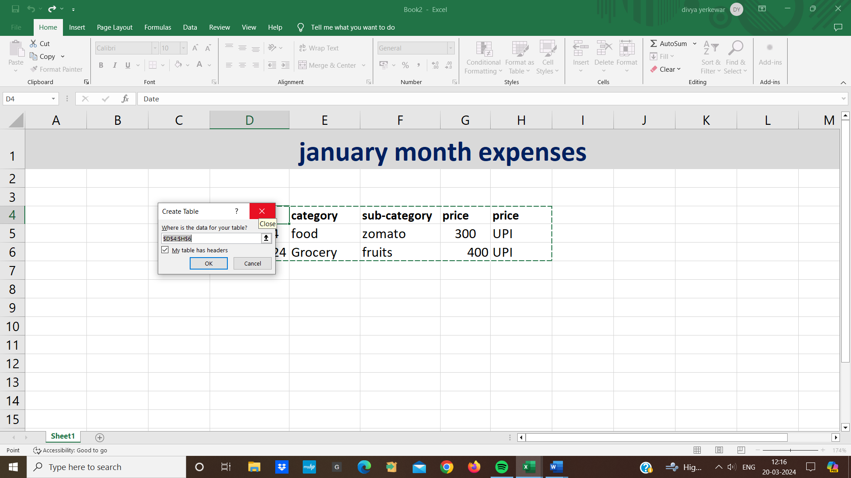

* which will convert all our data to a table.
* i click OK on it i have data in a table format .The table created we have a lot of options at the top right we can choose any color we want
* we will go to the file tab for save or click on Ctrl-s to save it.

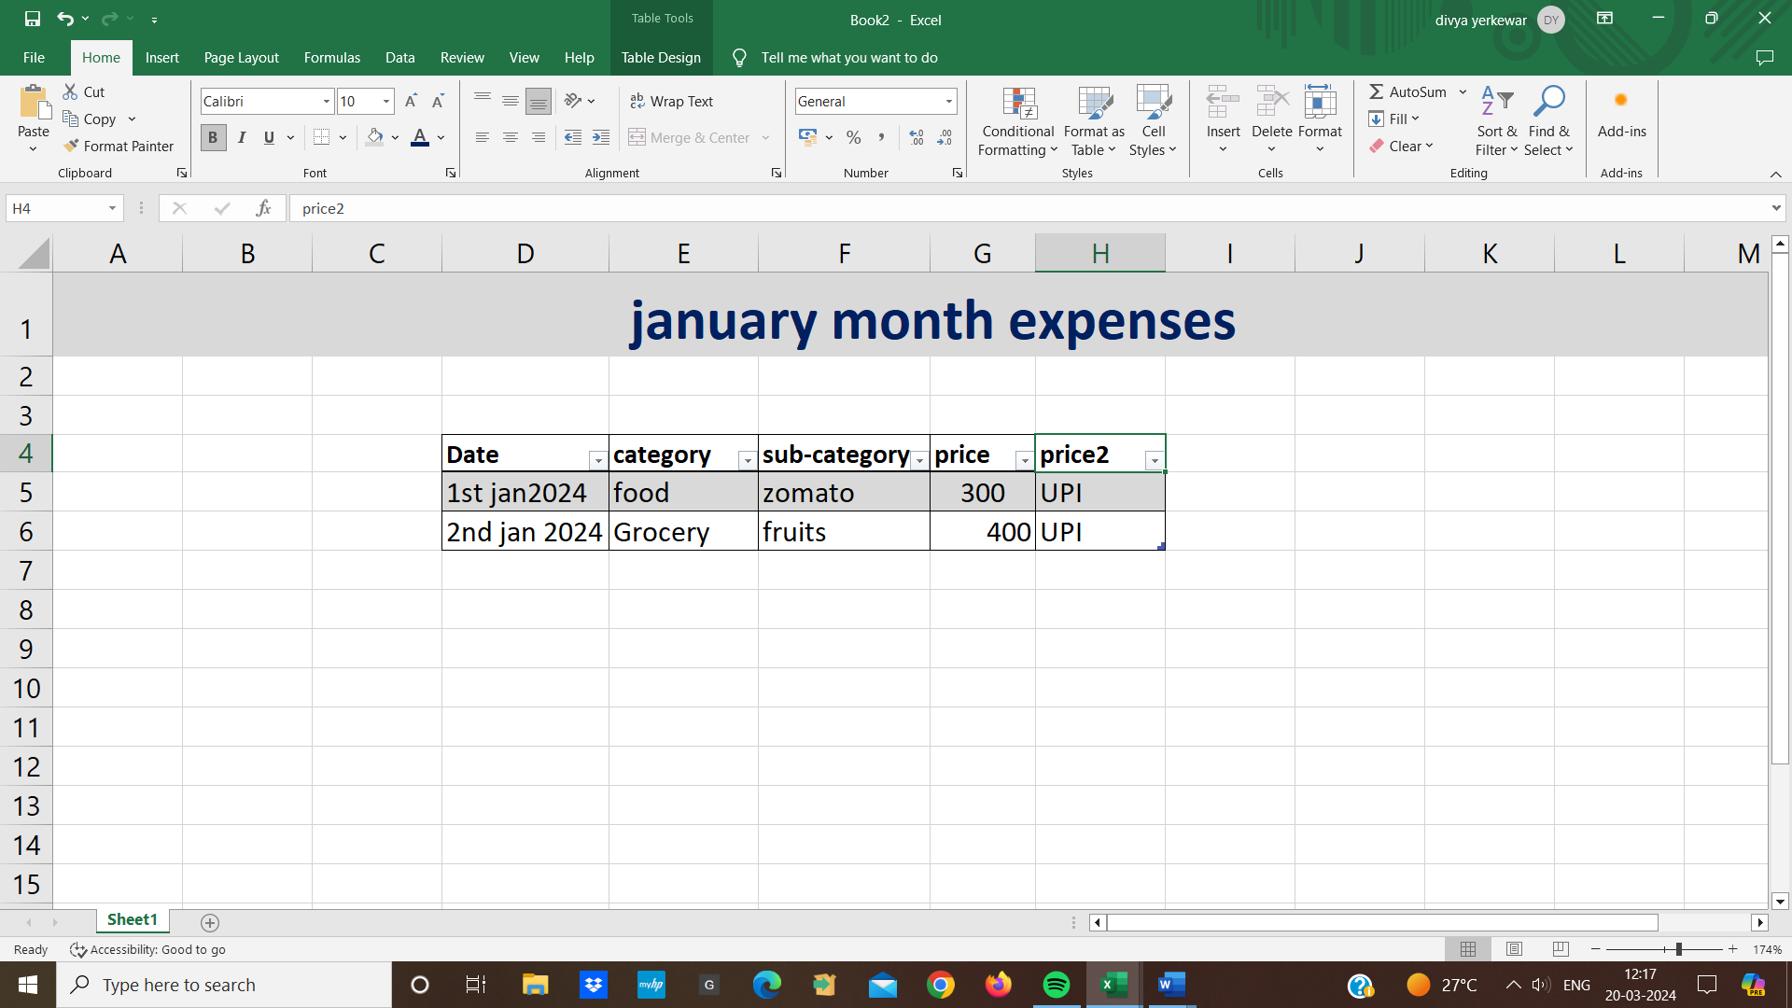

**Basic Functions of Excel:**

**1.Auto Fill:** Auto Fill automatically fills values in the order in which we are arranging.

* If i have a numbers and i start from 1 then 2
* Now all i have to do is drag it there by holding the Ctrl key. So I will get the values.
* We can use autofill on numbers, dates.

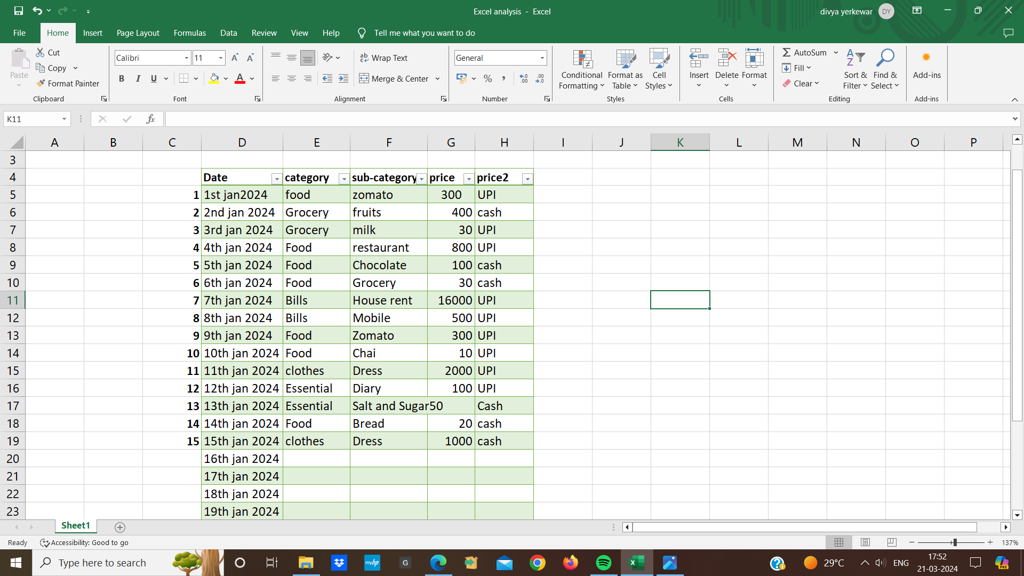

**2**. **Flash Fill:** Second function of Autofill is FlashFill

* The work of Flash Fill is to understand the pattern and fill that pattern
* If I have a list of full names and we start typing the first name in a new column excel can fill in all the first names.
* we just need to type a couple of examples and excel to figure out what we are trying to do.

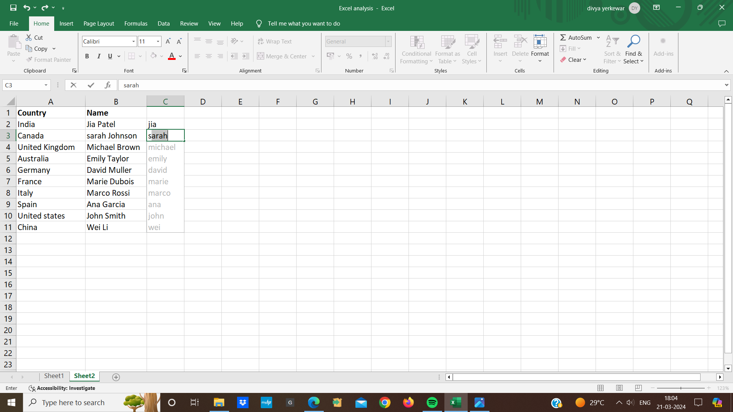

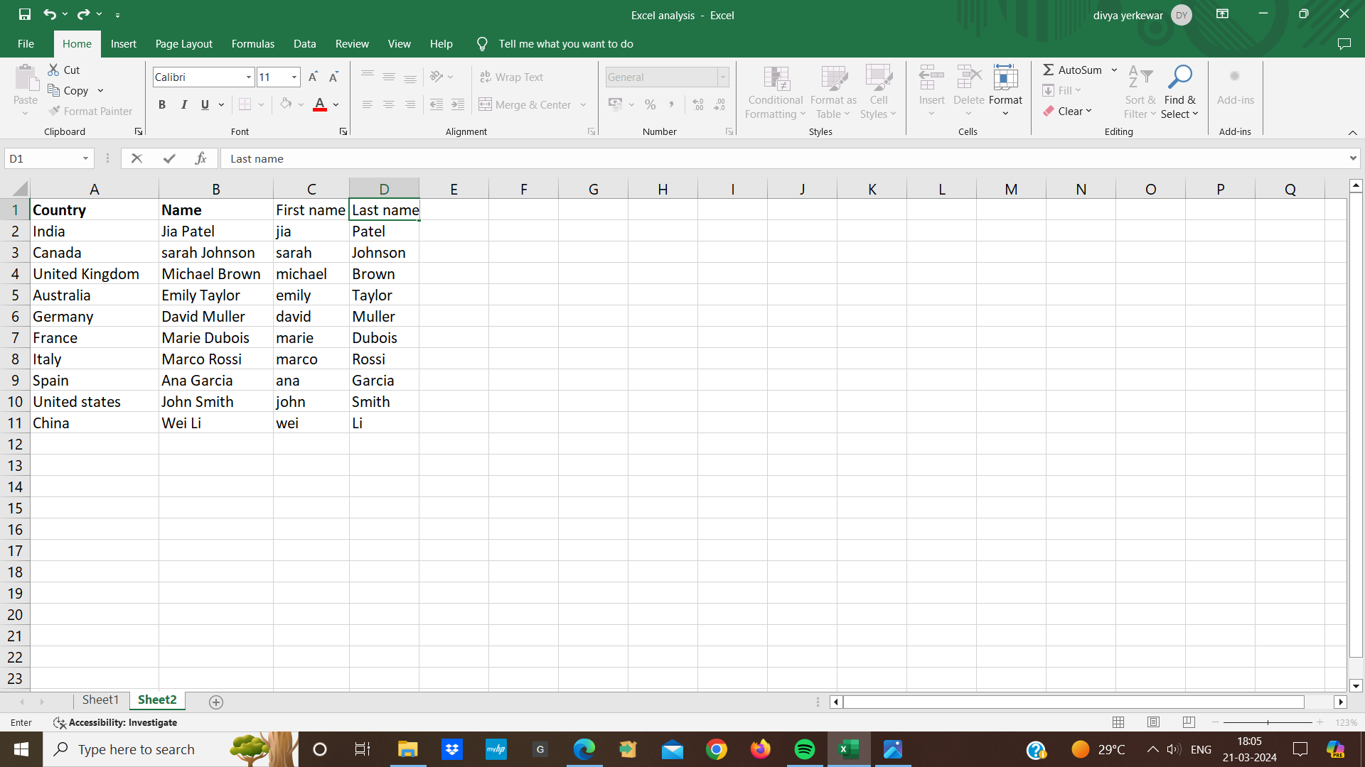

* suppose we don't have an option there. In that case .we can go to fill.
* In fill we have the option of flash fill.we can choose and use flash fill.
* It works with names, dates, whatever pattern we see I can flash fill with that pattern.

**3.Text To Column:** Text To Column means that we have data in some text format .

* We have comma separated data. It is a sheet in which we have electronics and devices and code.
* Means which are written in a paragraph.
* We have to separate it into columns
* if there is a data now i will choose the entire column in the data
* I have the option of text-to-column

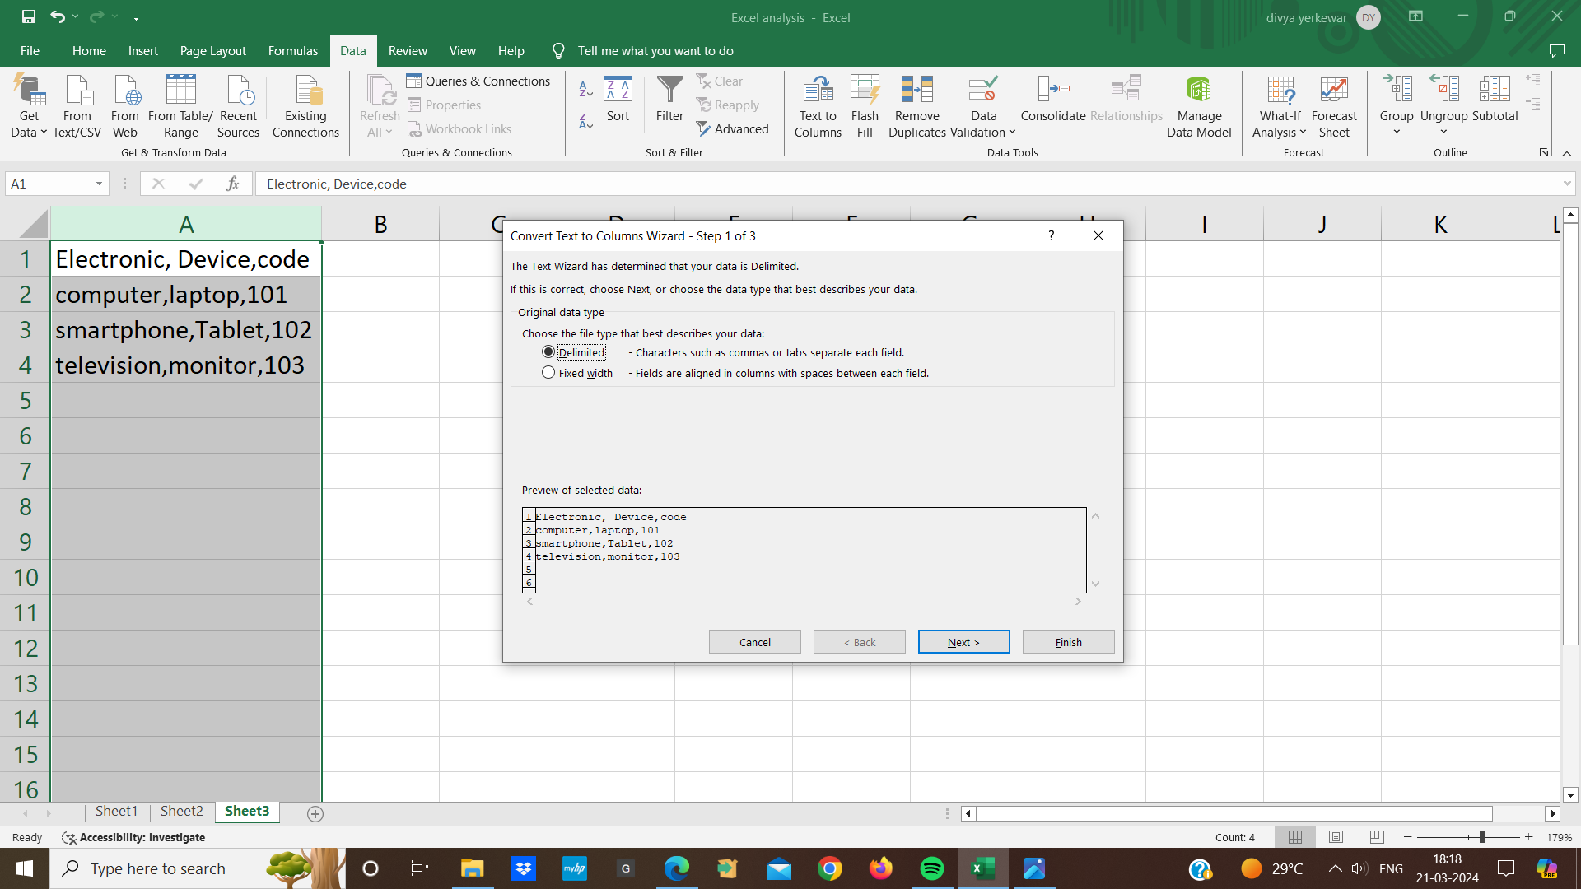

* Delimited means that it is separated from something
* so here this comma is separated. After delimiting, i will click next here
* Now we will see that i have the options of comma
* As soon as I choose a comma ,I have a computer in one column and other words in the other column.
* Now click next .

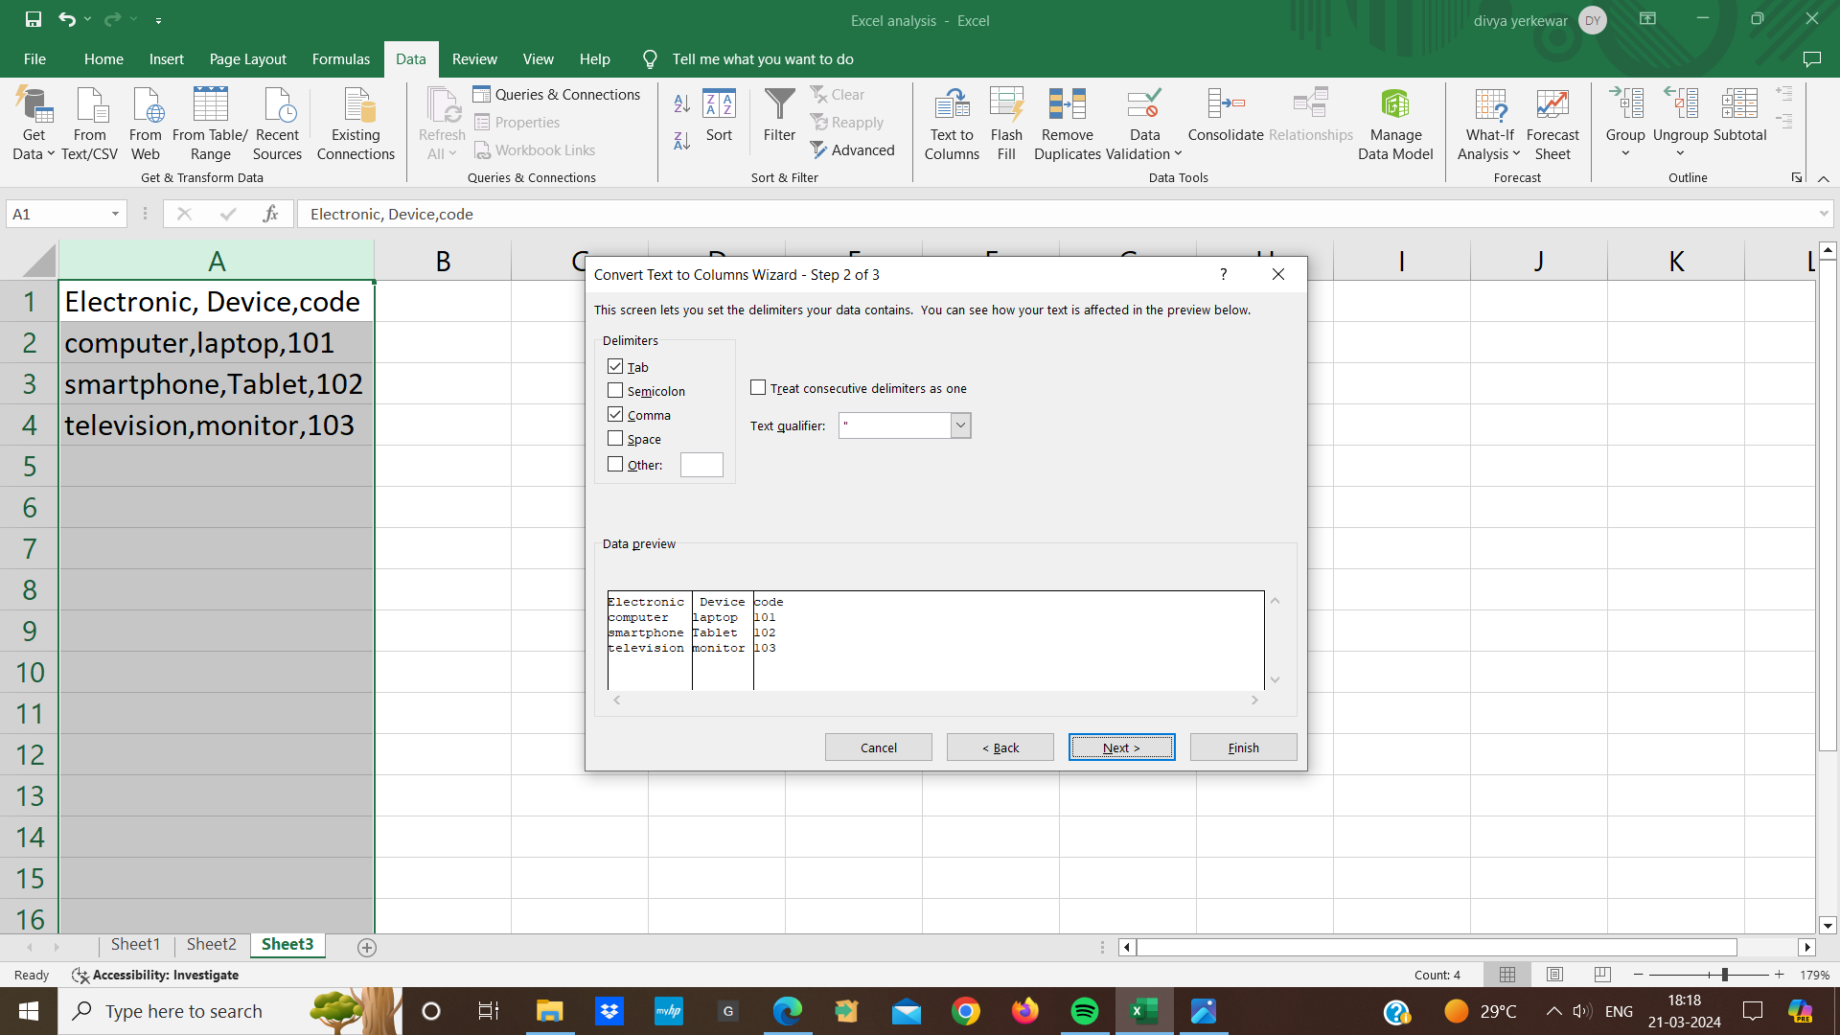

* We can choose the destination the destination will be B column

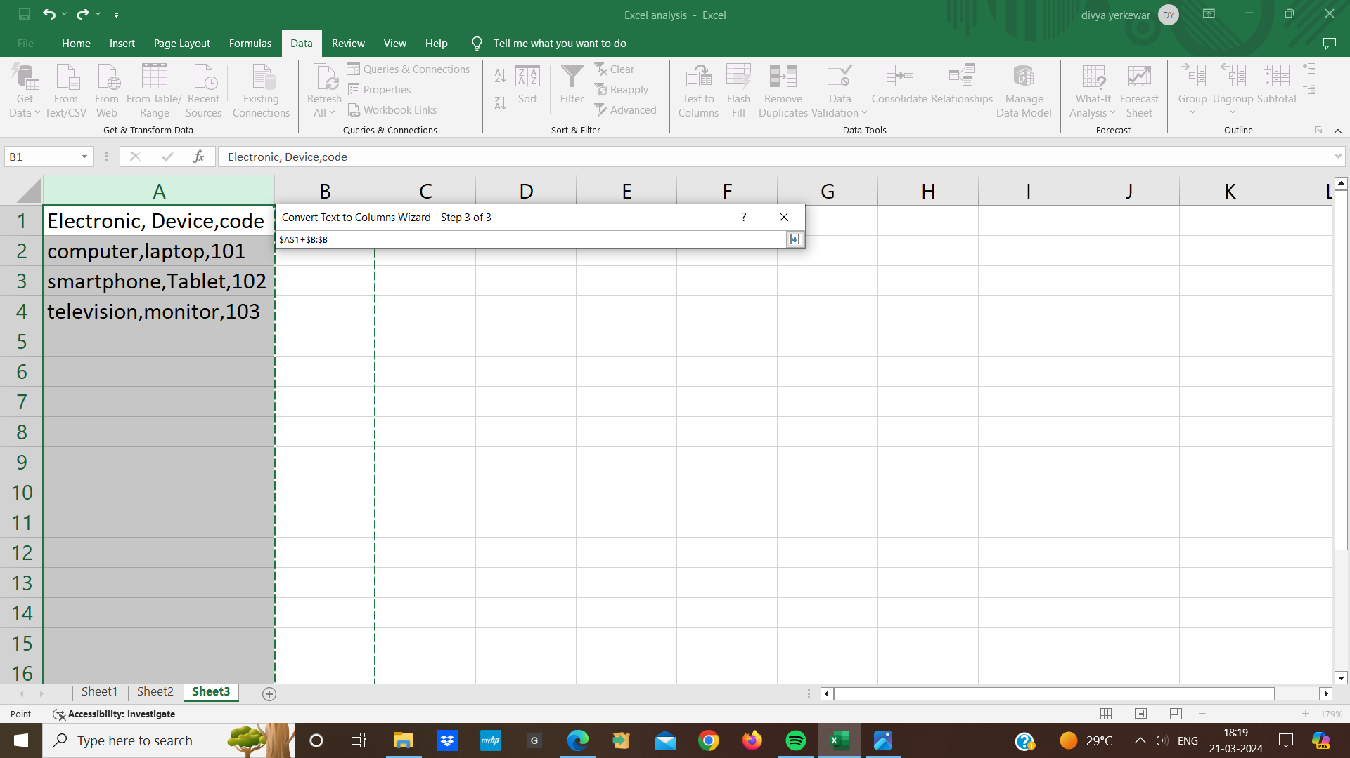

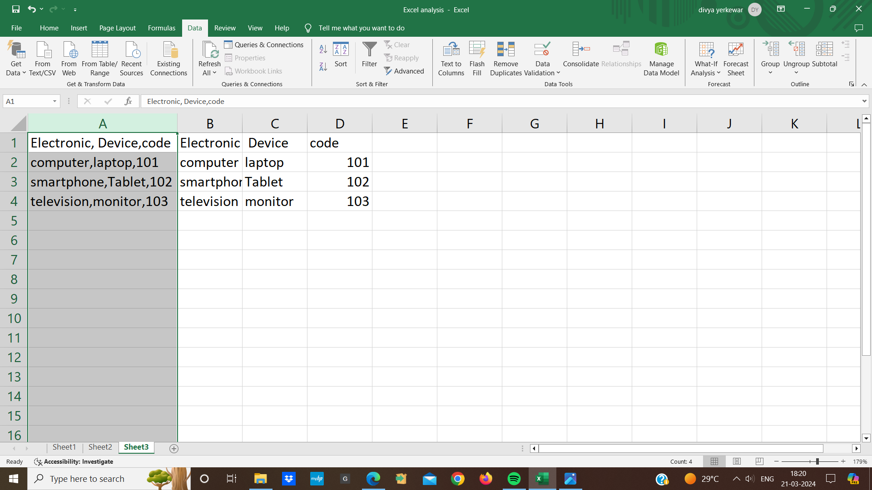

* So we will see here that I have some data.

**Basic Formatting In Excel:**

Excel provides us with different methods, different ways with which we can sort the data Also it changes with the data types that we are handling

* **For example:** If I have a date now, I have the dates in ascending order. I want to go with the descending order. if i had got these dates randomly and i had to store it in descending or ascending. So, all i need to click on any cell we will go to a homepage. On the homepage, we will see the option of sort and filter on the right hand side and oldest to newest, i want to go to the newest date from oldest so i will choose oldest to newest so it will be sorted in that way

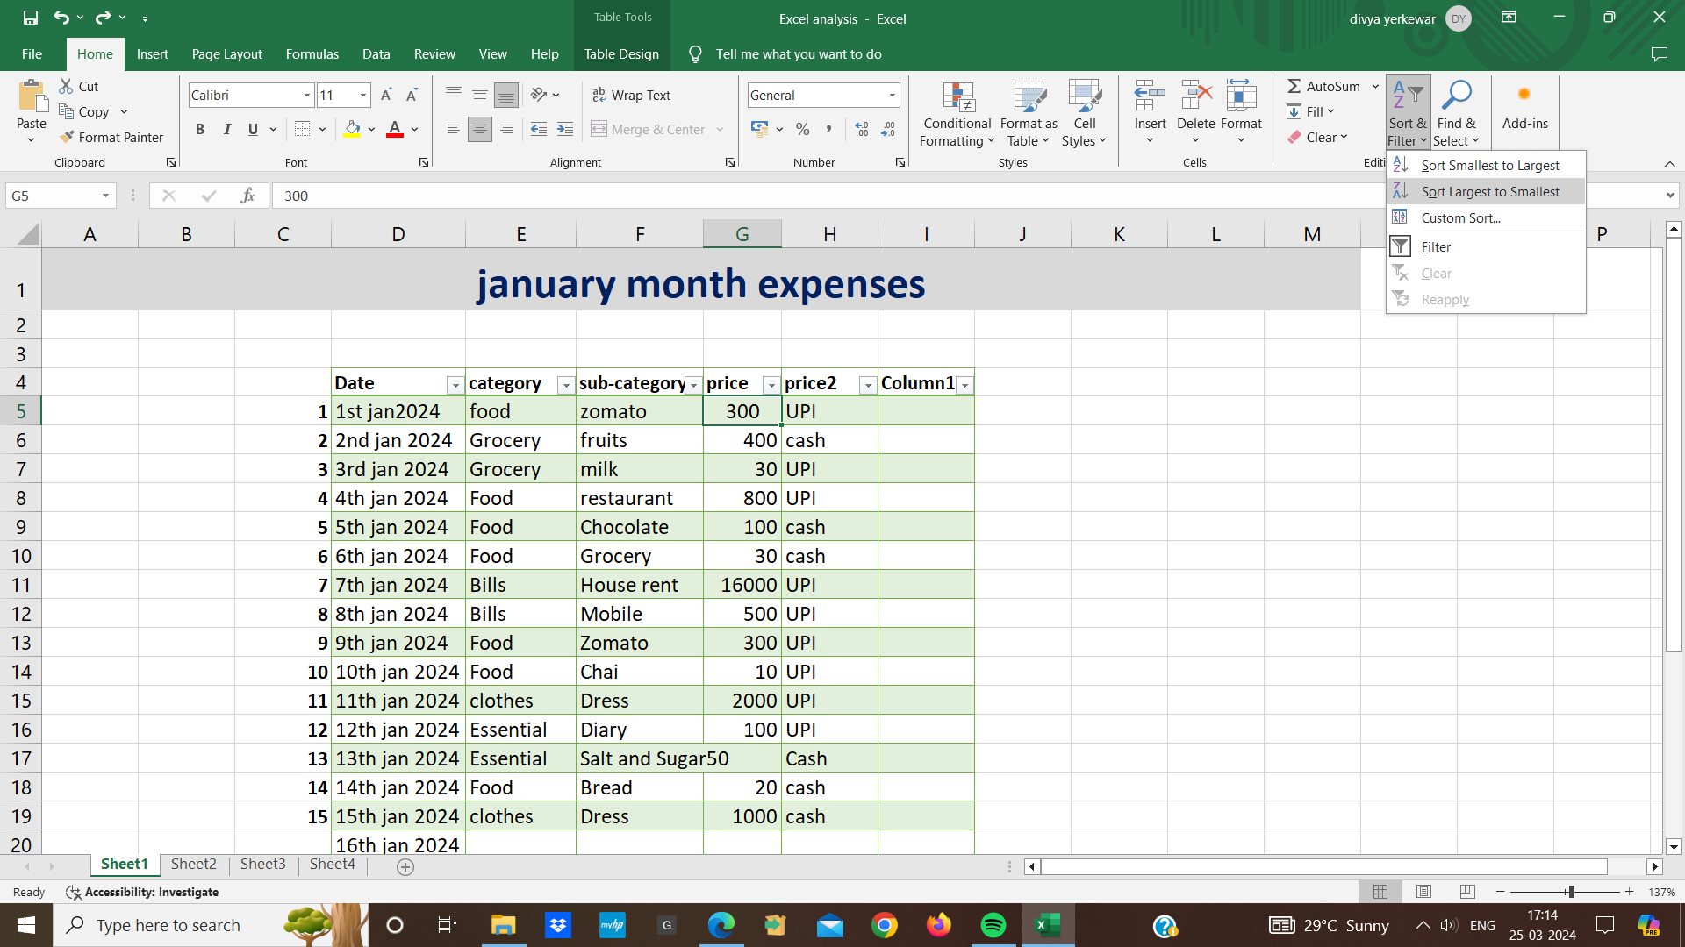

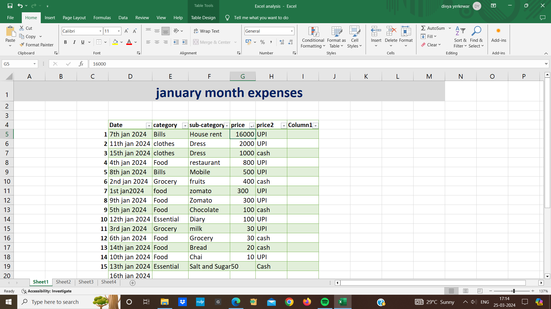

* So in the same place we will see the options of food in the options of food. The data we have here is in the text format so again we have to sort it if we want to sort it in A to Z ascending order. In this way our data has been sorted
* same goes with amount in the column i will choose if i want to filter the data on the basis of amount then largest to smallest In that case again we have chosen the cell select the sort and here we will go to largest to smallest so the highest values will comes up first and it goes down to the lowest values.
* Also there are different methods on which we can do sorting
* **For example:** we can sort the data on the basis of color . i have different colors in payment mode

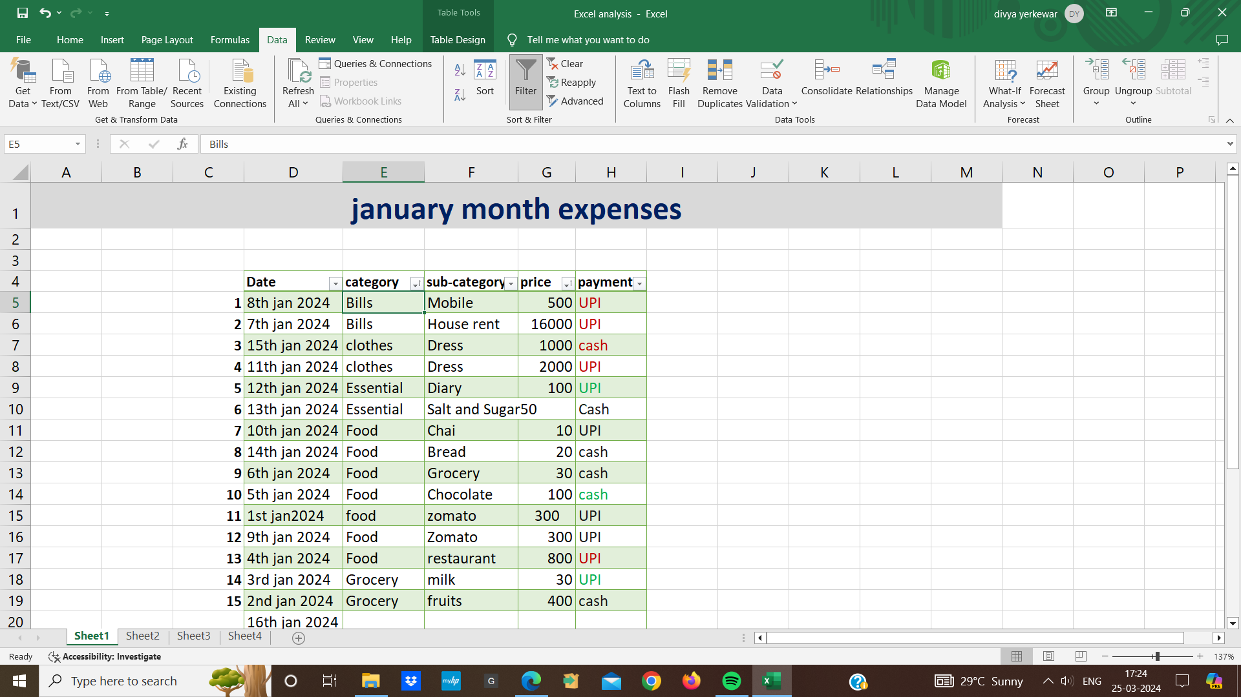

* first we choose payment column we will see an arrow in payment column
* As soon as i click on it the entire column chosen All i need to do is go on data we will also see the sort option in the data we choose this sort
* After choosing the sort we will get apop-up here
* In the pop-up we have to sort by on whose basis we have to sort so i have to sort it on the basis of payment method i have to do it on the basis of cell color front color is also an options here Or conditional formatting icon is also an option
* For example: i can go to filter we also have a shortcut that we can press CTRL,SHIFT and L. By pressing this we can see that filters i have been added we can apply any filter here i want only cash data here select the cash and press ok
* And only cash data will be visible here.
* 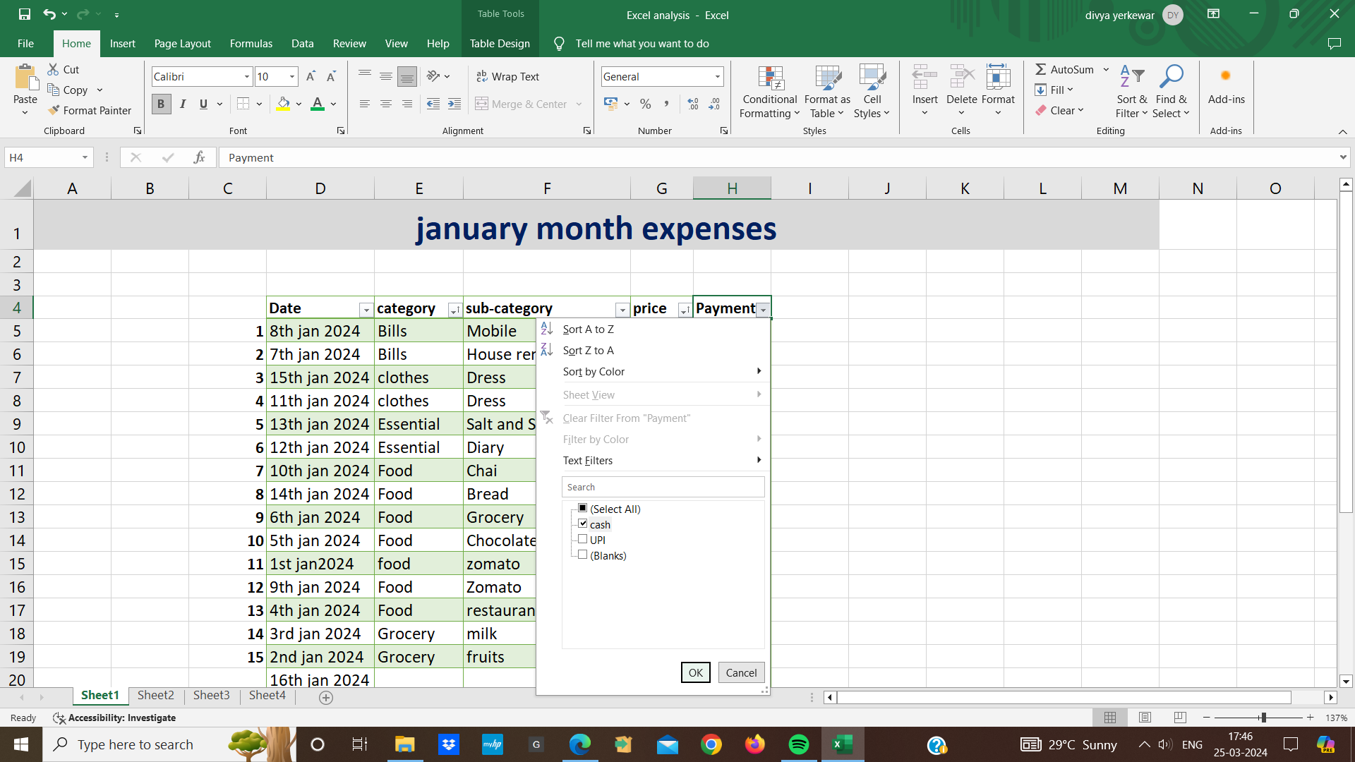
* 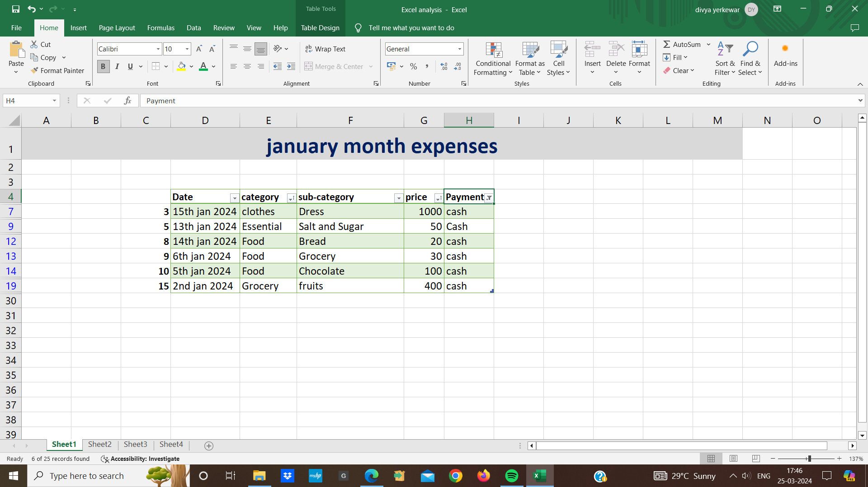
* Similarly if i want both cash and card data then both cash and card data will be displayed here

**Basic Formula /Functions:**

Basic operations that is additions , subtraction,multiplication and division

* If i click on both of two cells so we will see down here that i have the sum here that is 350 the count has come that there are Three cells and the average value of both of them is 175.

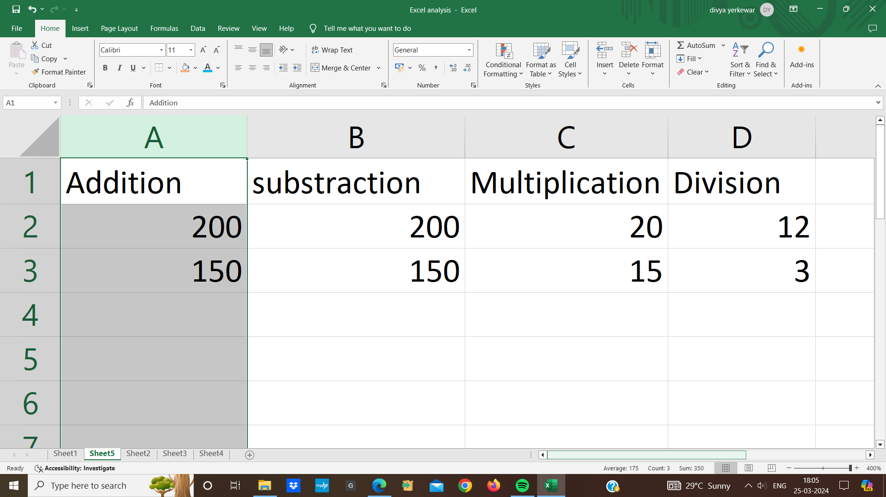

* Similarly we right click here we'll see a lot of things here if we want the minimum value, maximum value here we can get it here too

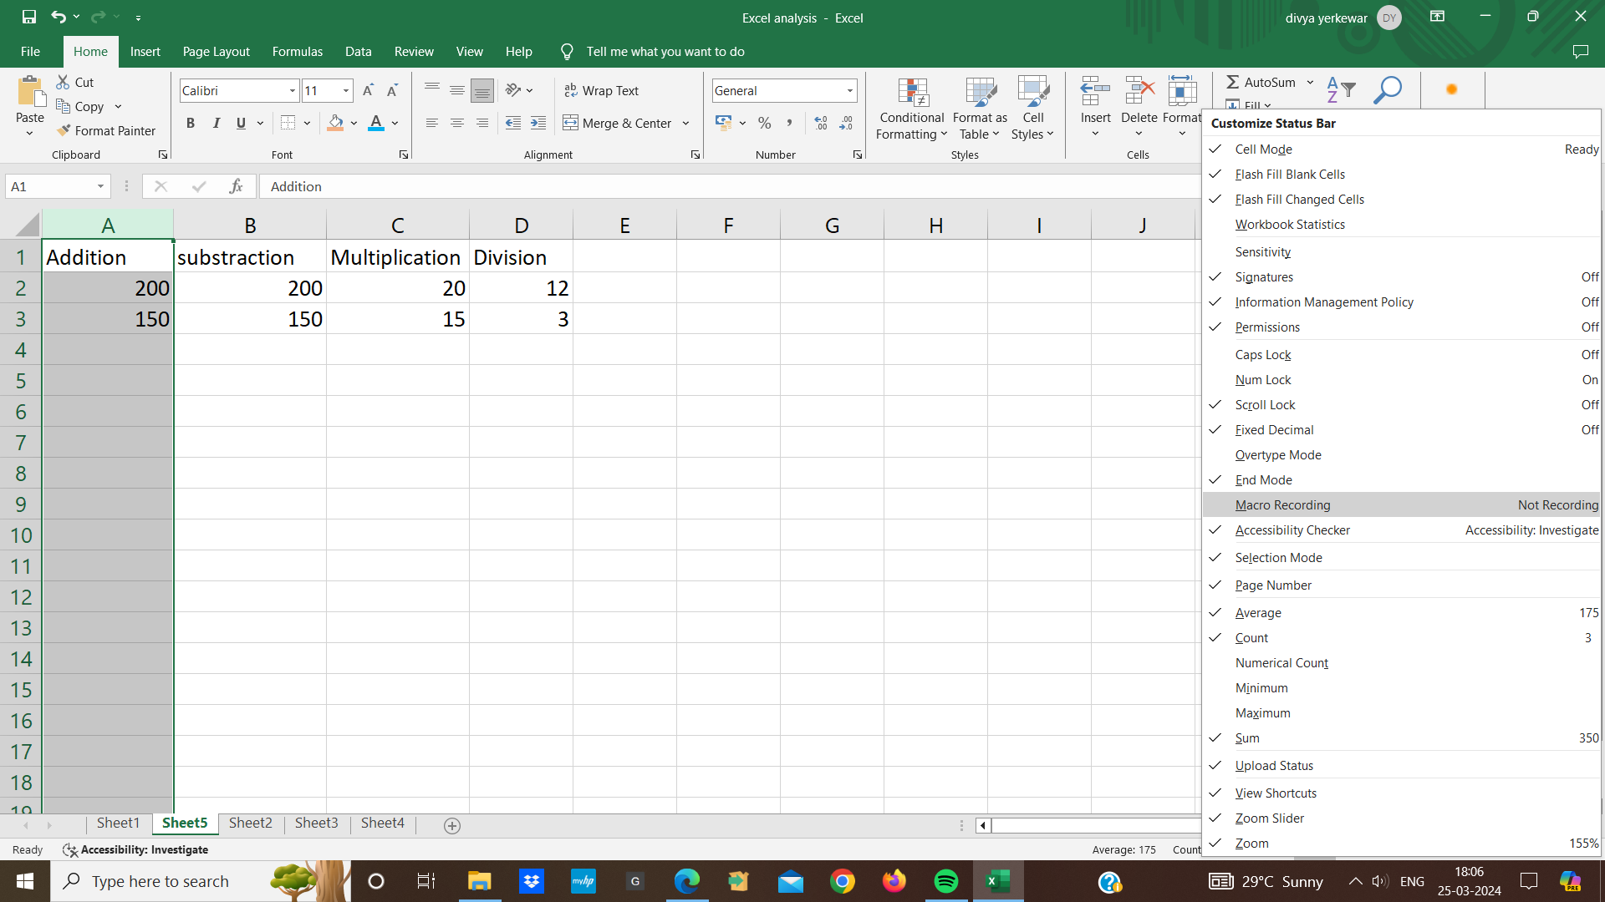

* Secondly, if we want to apply the addition formula here between the cells All i need to do is write equal to after equal to we enter first cell A2 and we will put a plus symbol in this and we select second cell that is A3 then i press enter and i will get it here.

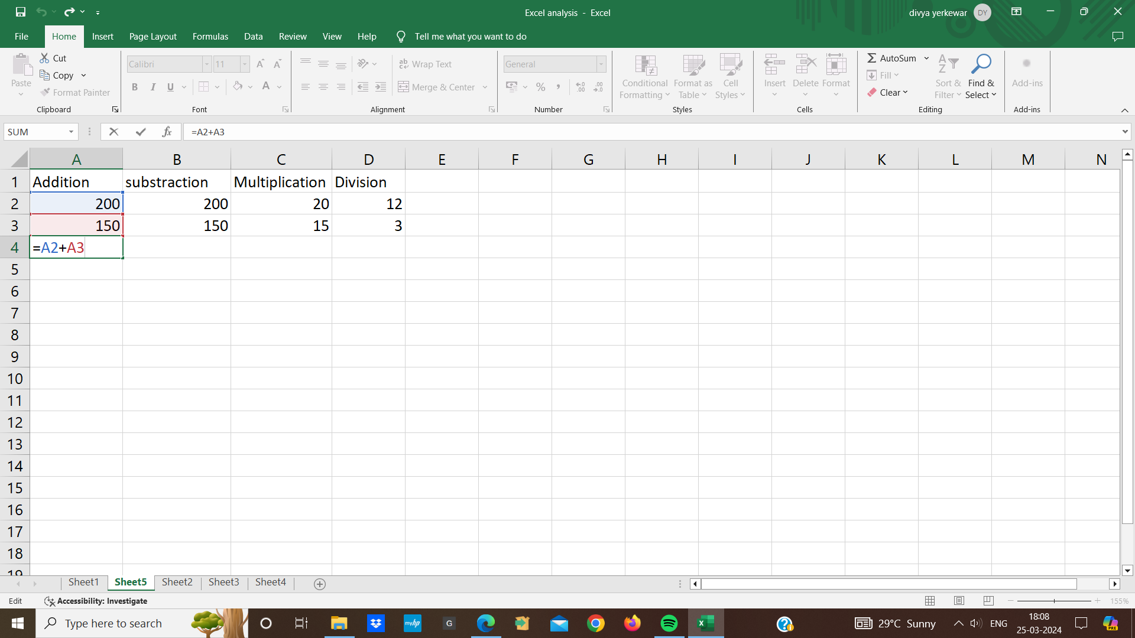

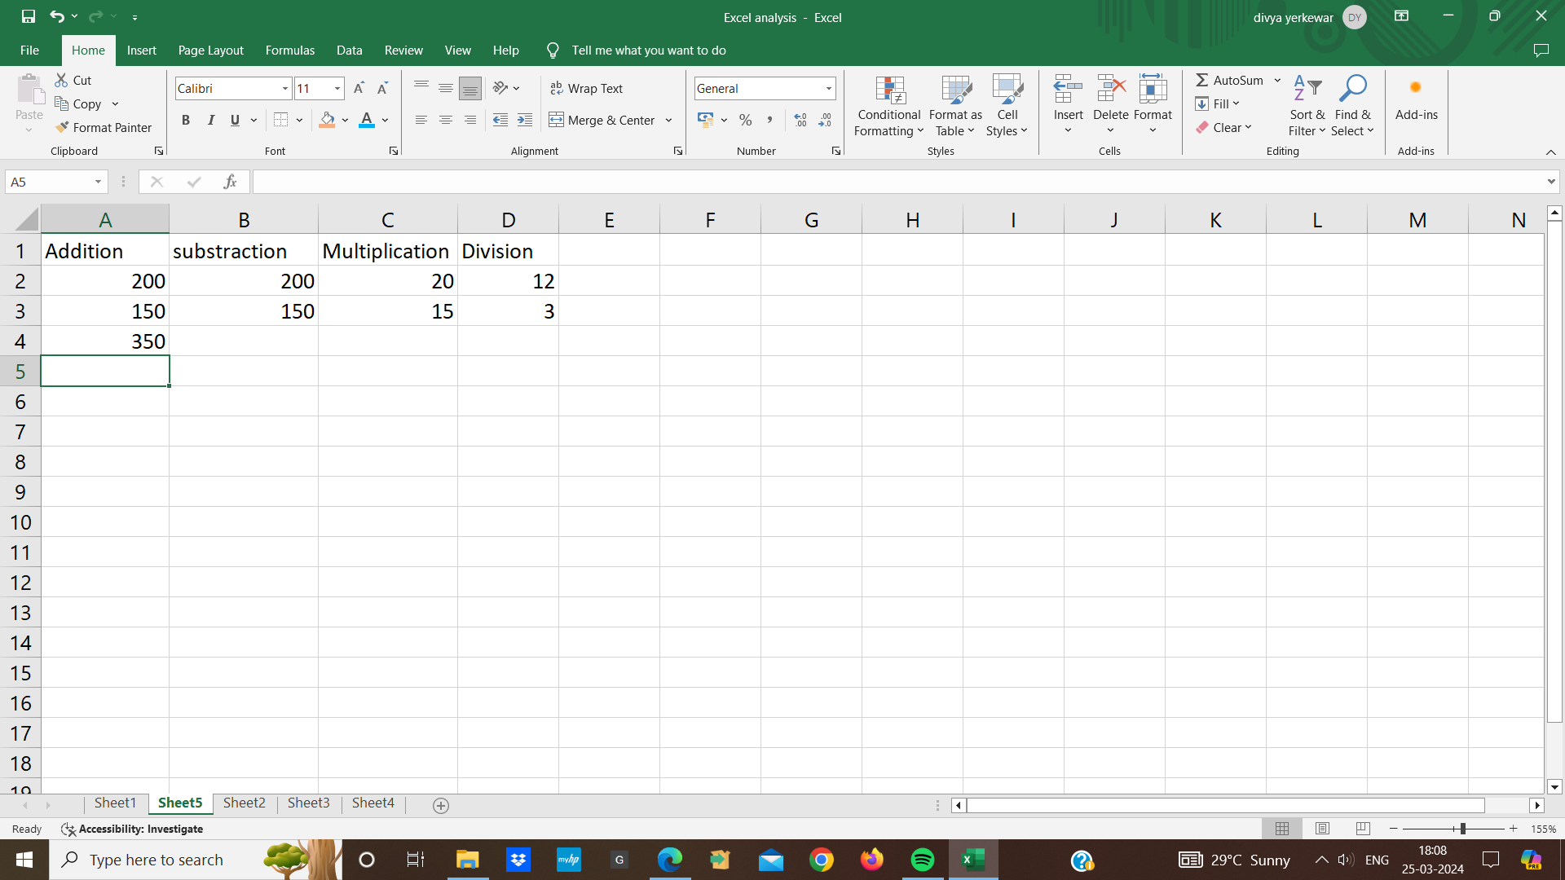

* Similarly we can do the same things with functions too.
* In the cell again we will put equal to we will use the sum here again we will choose the cell here

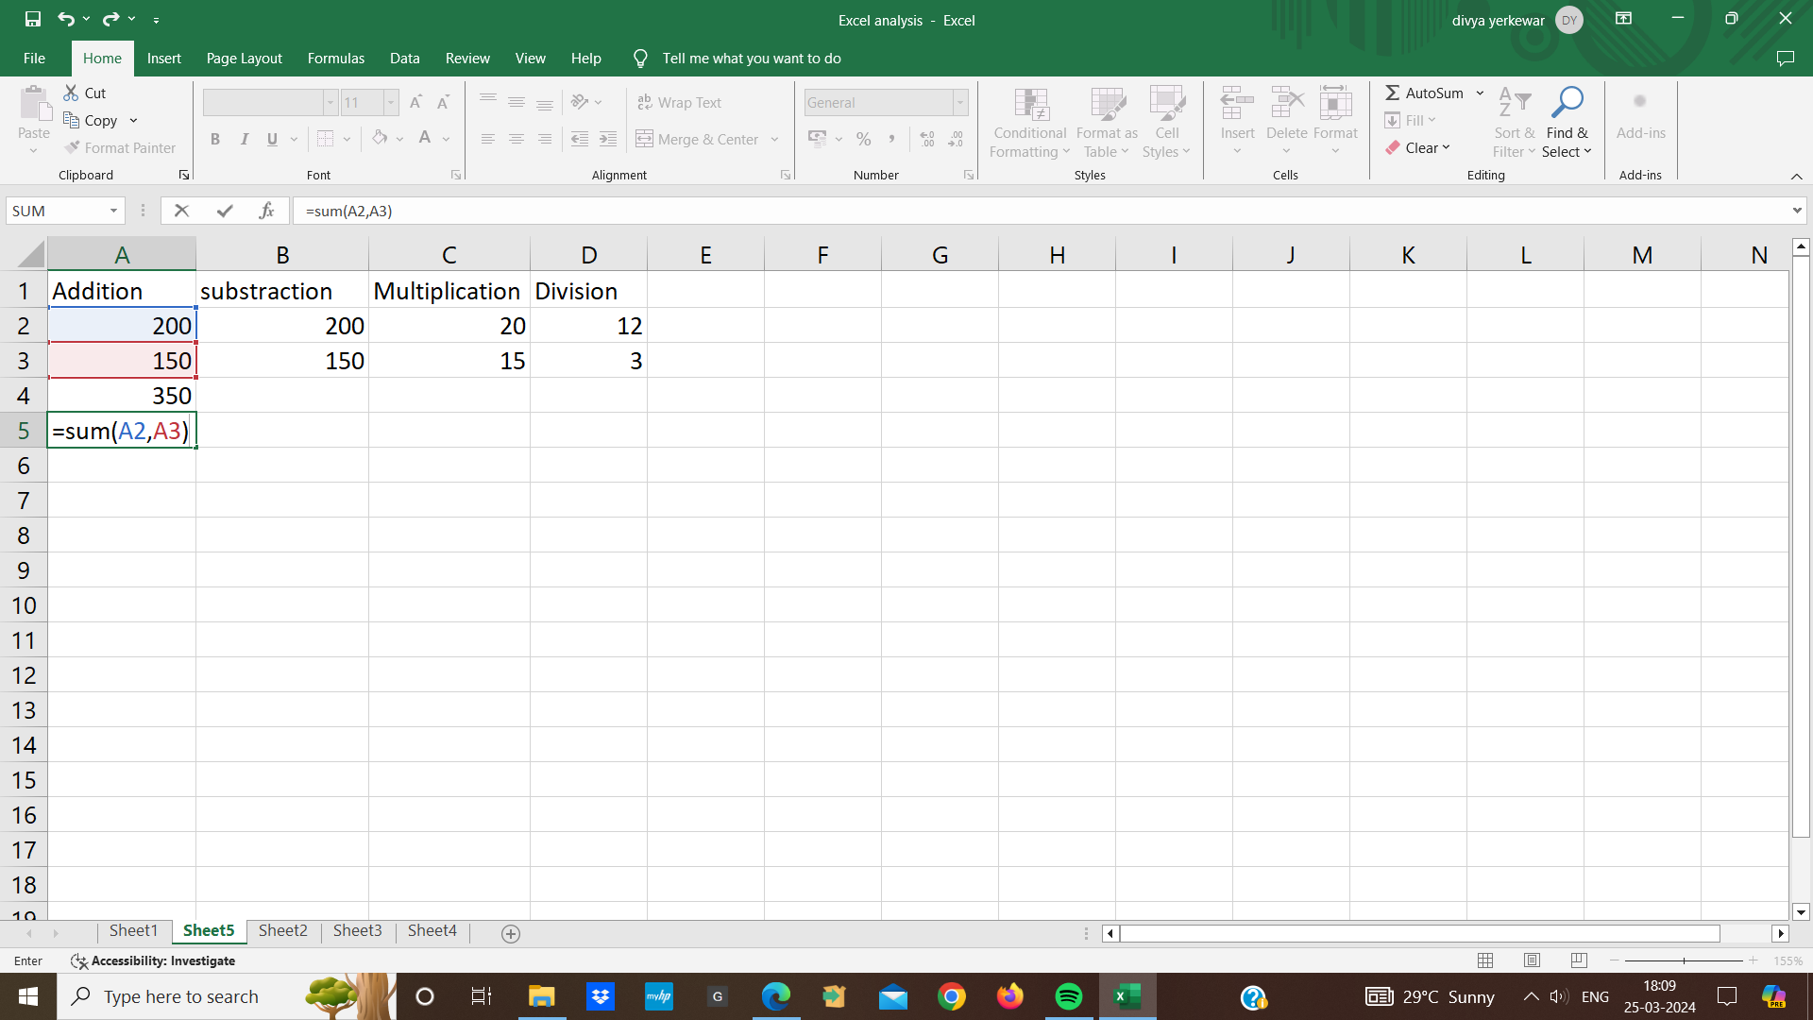

* The same goes for subtraction for subtraction we need to do is equal to we will select the first cell and second cell as soon as i press enter the output is here that 200 minus 150 is50

**Text functions in excel:**

1. **Concatenate Function:**

* We can use concatenate methods to get all the data in one cell
* Type the function into a cell where we want to combined text we start with an equals sign (=CONCATENATE)
* After typing the function name we type an open parenthesis “(“.
* Inside the parenthesis we can add the cells we want to combine , separated by commas
* for ex:

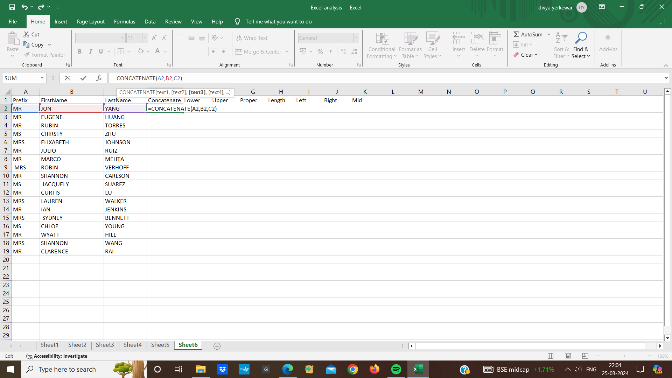

* Close the parenthesis and press enter excel then display the combined text and when we double click then in the cell the combined data comes in the columns

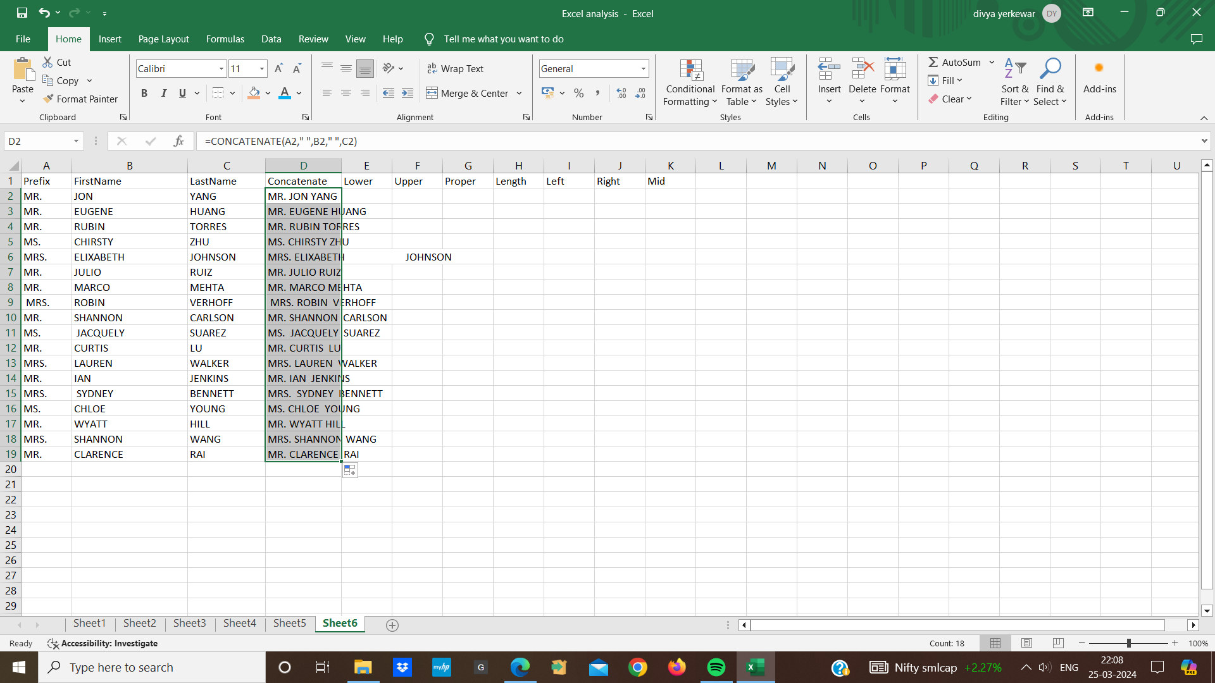

**2.Lower Function:**

* The Lower function in Excel is used to convert all letters in a given text string to lowercase
* click on the cell where we want to display the converted lowercase text
* type the lowercase function (=lower)
* After the opening parenthesis we input the text we want to convert to lowercase
* we can either specify a cell that contains the text we want to convert
* for ex:

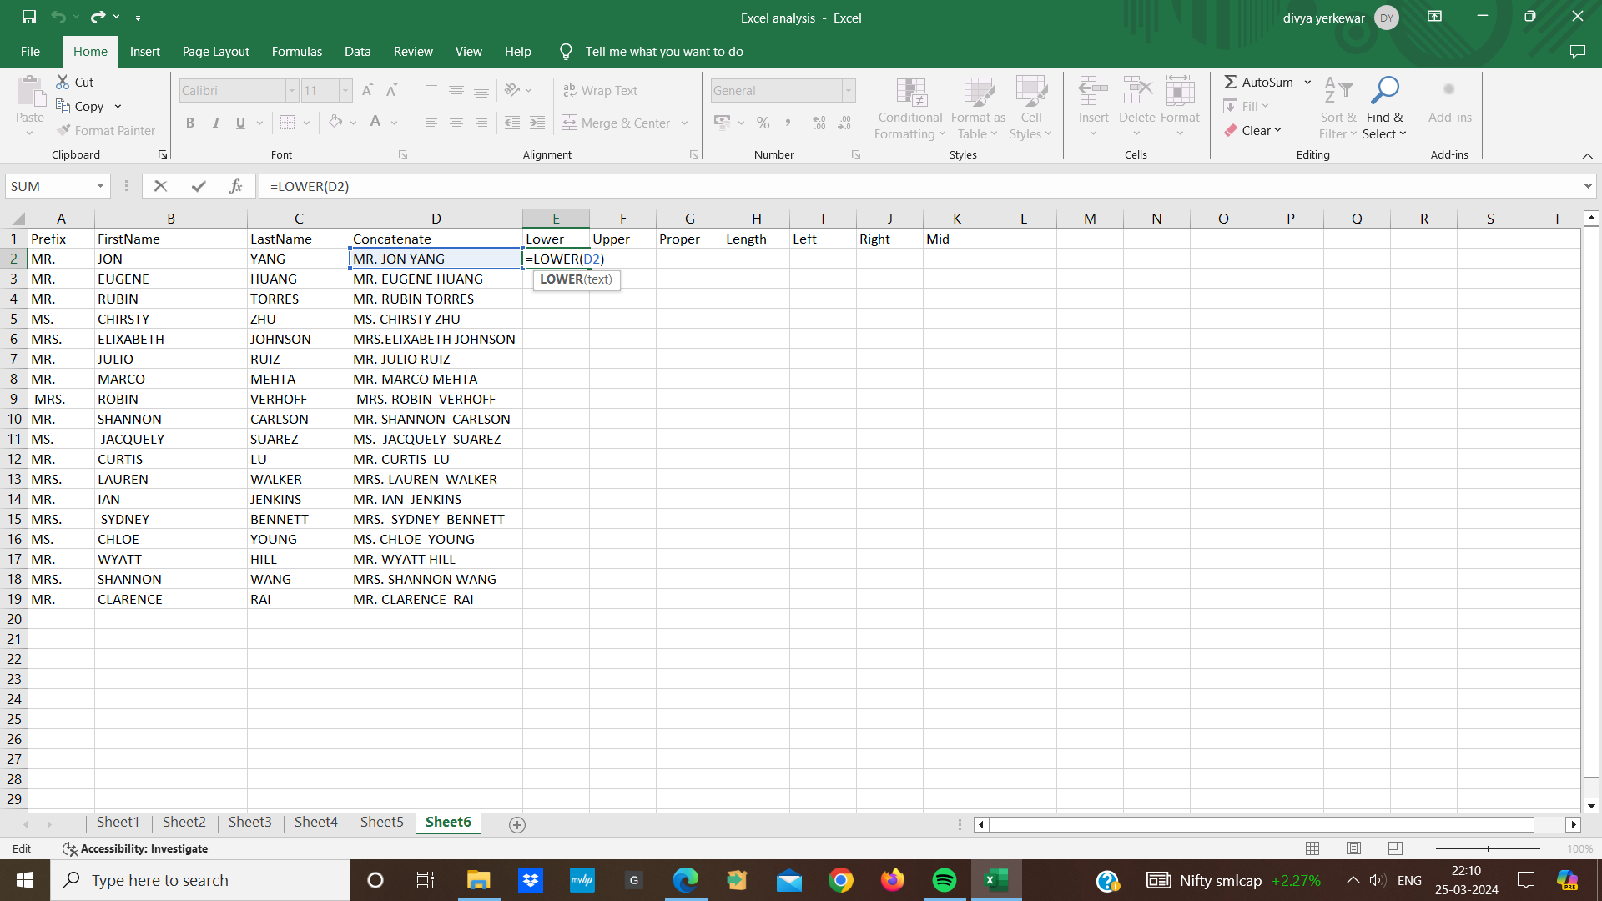

* close the function and press enter the cell will display the text in lowercase.

**3. Upper function:**

* The Upper function in excel is used to convert all letters in a text string to uppercase
* Click on the cell where we want the converted uppercase text
* type the Upper function (=UPPER) into the cell
* inside the parentheses we input the text we want to convert to uppercase
* we can specify a cell that contains the text we want to convert
* for ex:

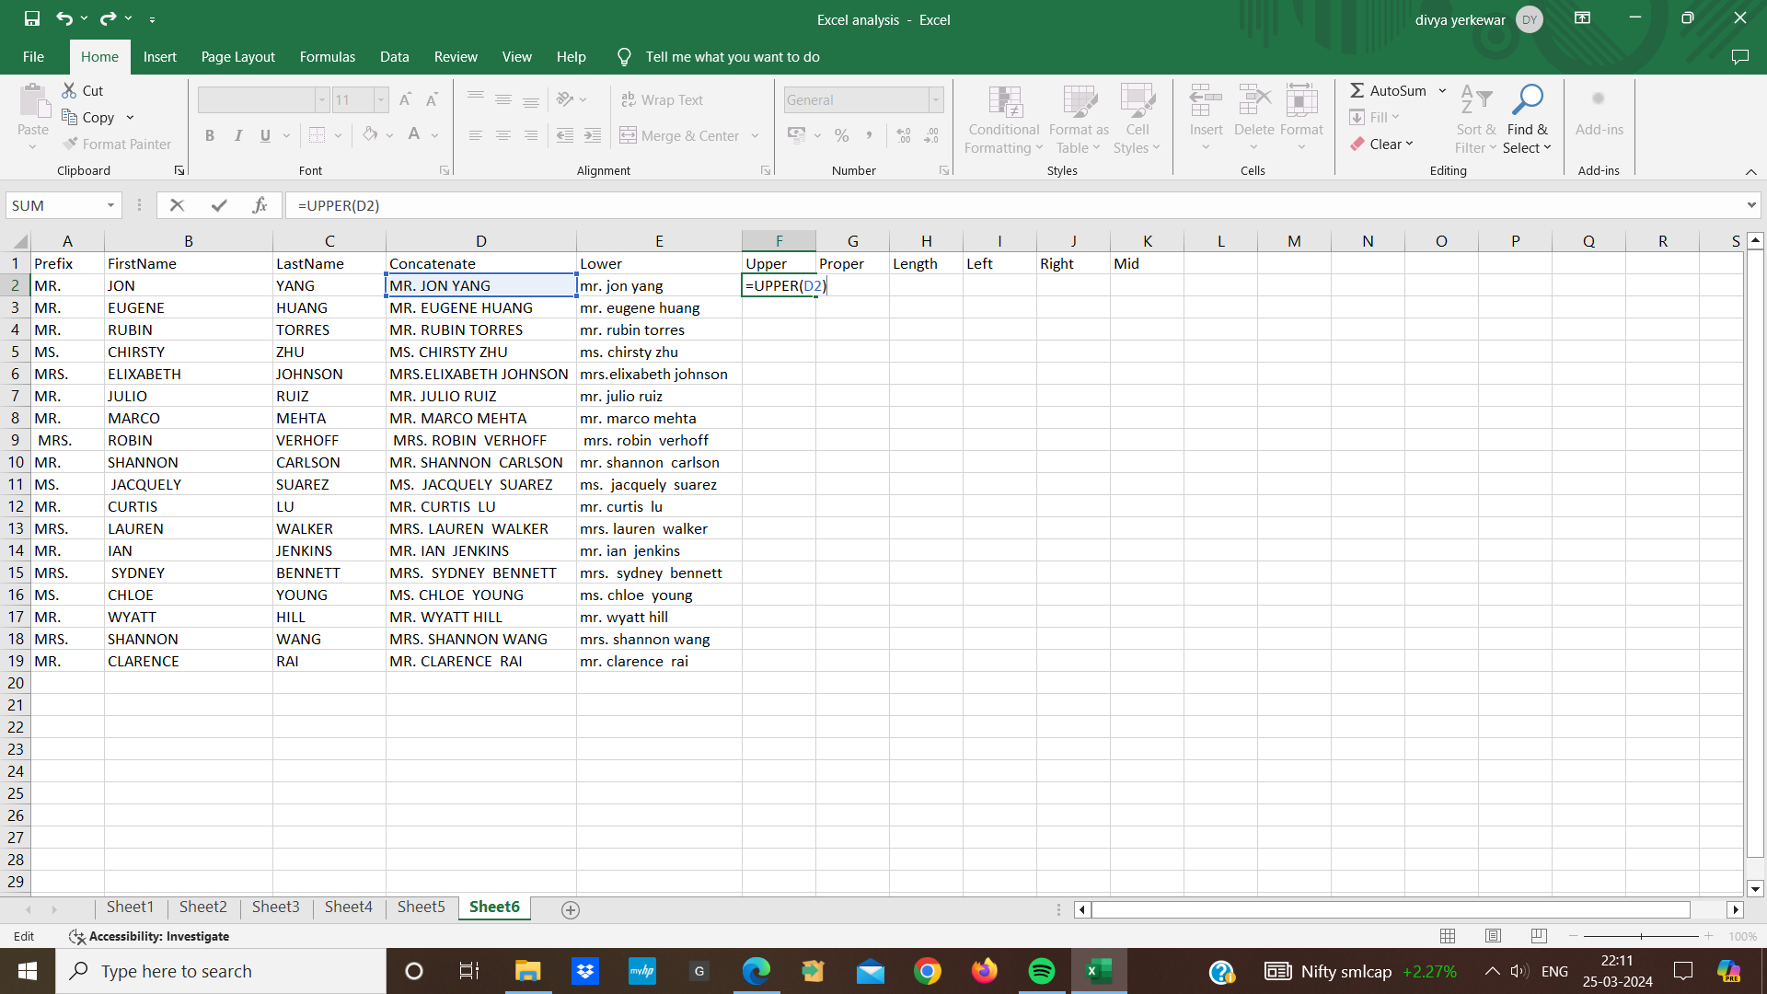

* close the function after the text and press enter the cell will display the text in uppercase letters.

**4. Proper Function:**

* Proper function is used to convert text to proper case
* It capitalizes the first letter of each word in a given text string and converts the rest of the letters to lowercase.
* Choose the cell where we want the properly capitalized text
* Type the proper function (=PROPER()) into the cell
* Inside the parenthesis we input the text we want to convert
* we can either type cell that contains the text we want to convert

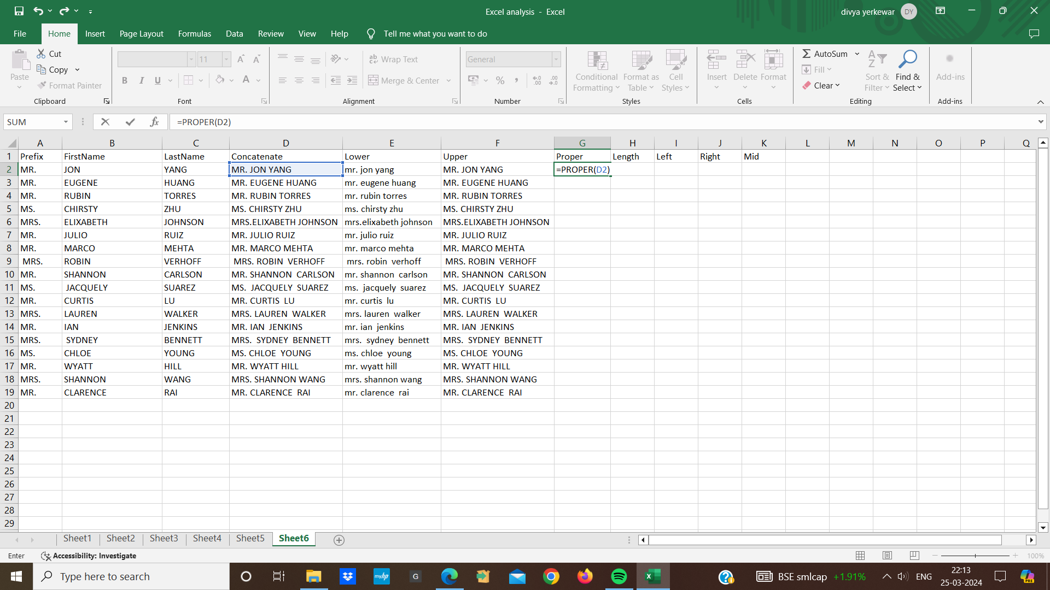

* Add closing parenthesis after our cell and press enter. The cell will display the text with the first letter of each word capitalized and all other letters in lowercase.

**5. Length function:**

* Length function calculate the length of text
* It counts all the characters in a specified text string,including letters,numbers,spaces
* Click on the cell where we want the length of the text to be displayed
* type the length function (=LEN( )into the cell
* After the opening parenthesis we input the cell contains the text

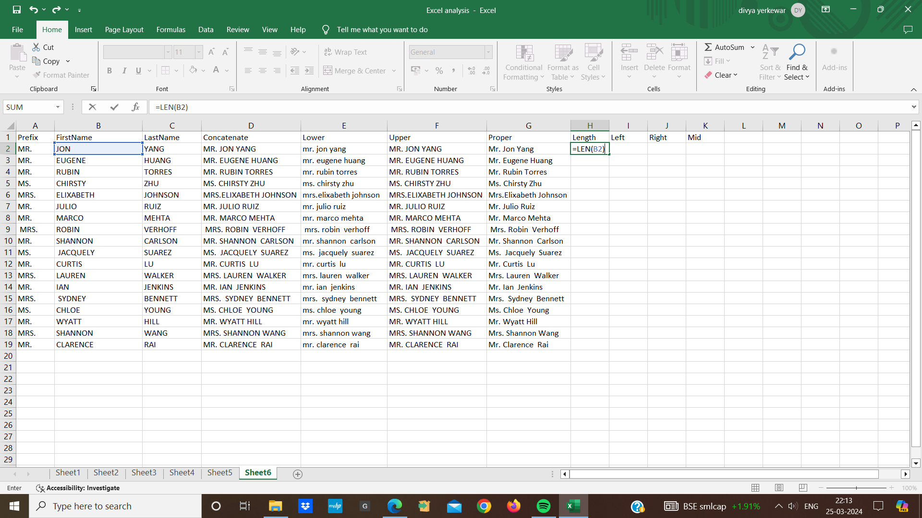

* put a closing parenthesis after the text and press enter and the cell will display the number that represents the length of the text string.

**6. Left Function:**

* Left function allows us to extract a specific number of character from beginning of a text
* Suppose the first name “jon” is in cell
* We choose the cell where we want the extracted first letter
* In cell we type the formula( =LEFT(F2,1))
* And press enter after pressing the enter cell I1 will display the letter “J” which is the first letter of the first name “jon”.

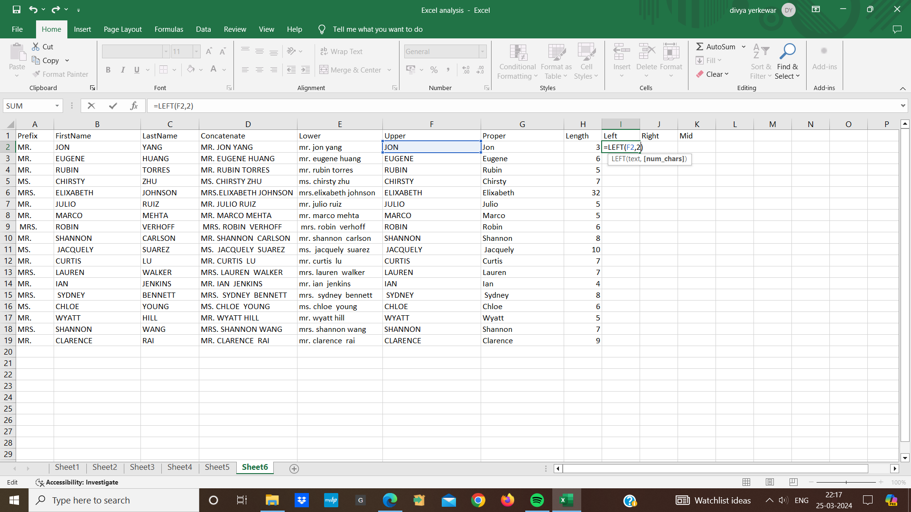

**7. Right function:**

* Right function is similar to left function but it extract a specified number of character from the end of a text
* First we choose the cell where we want the extracted character
* Type the right function (=RIGHT()) into the cell
* we enter the cell in the formula (=RIGHT(F2,1)
* And press enter after pressing the enter cell J1 will display the letter of “n” which is the last letter of the first name “jon”.

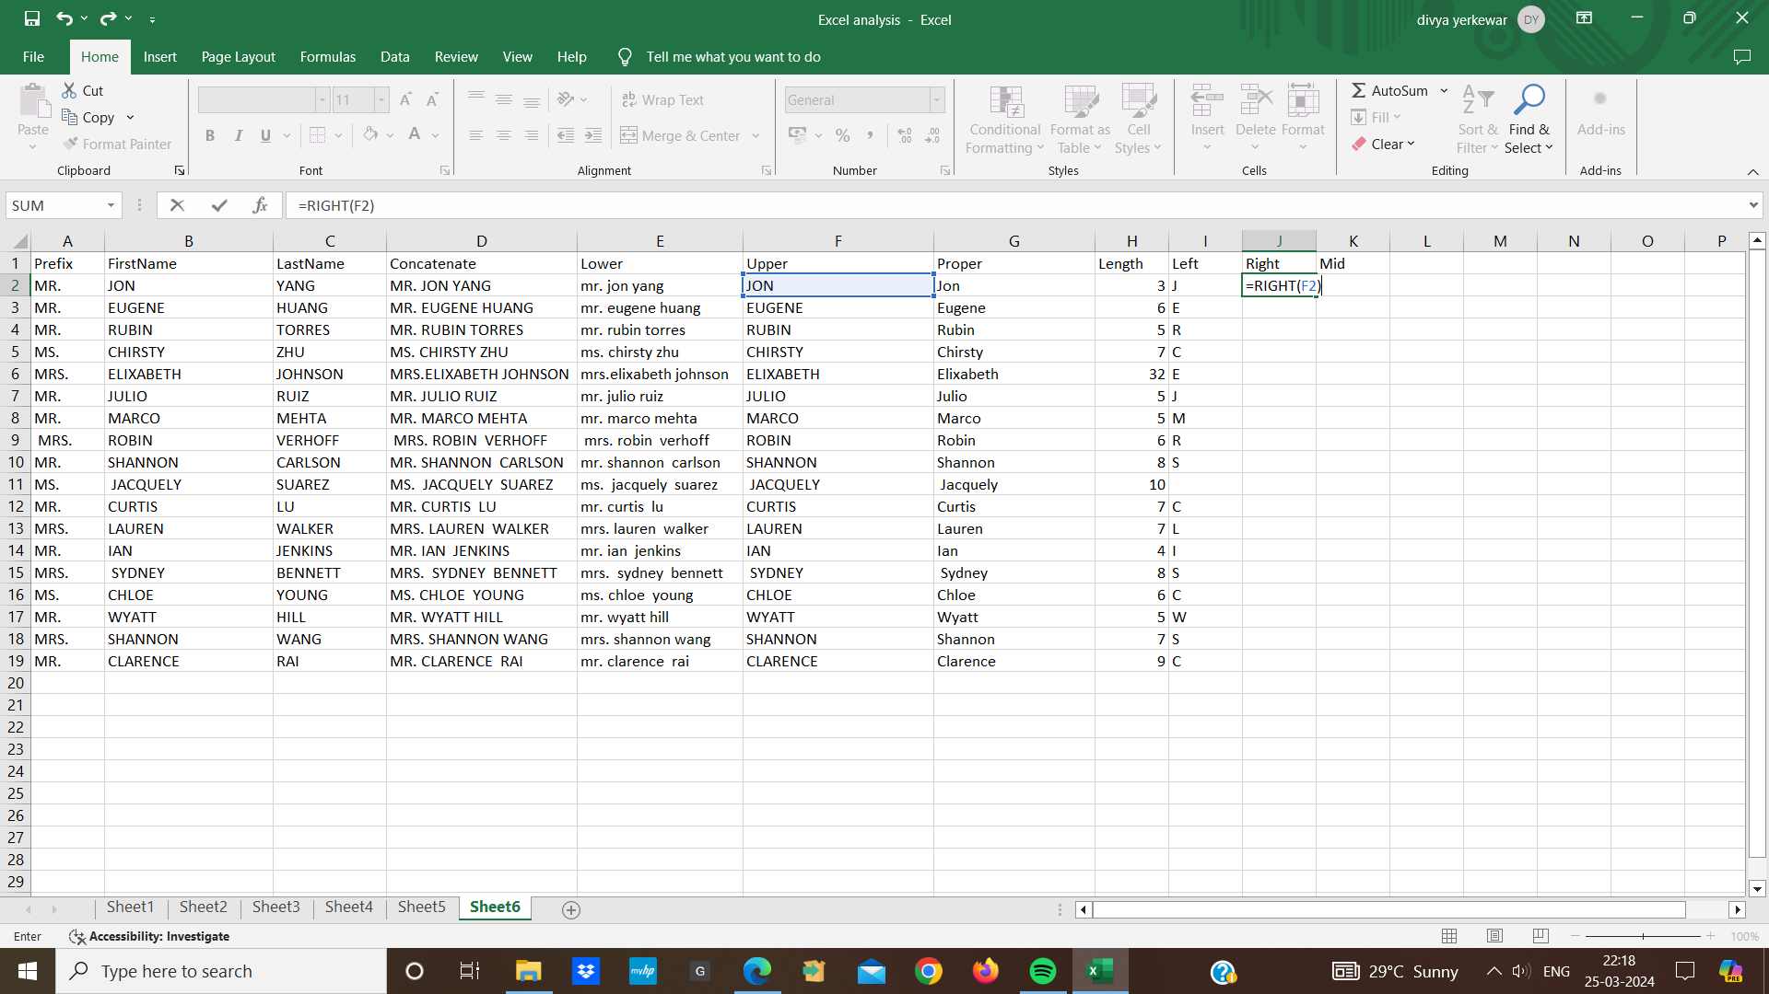

**8.Mid function:**

* The mid function extract a specific number of character from a text string starting at any position we want
* Choose the cell where we want the extracted characters
* Type the mid function(=MID()) into the cell Specify the text ,starting position and number of character
* Add commas between the three parentheses and press enter cell will display the extracted characters.

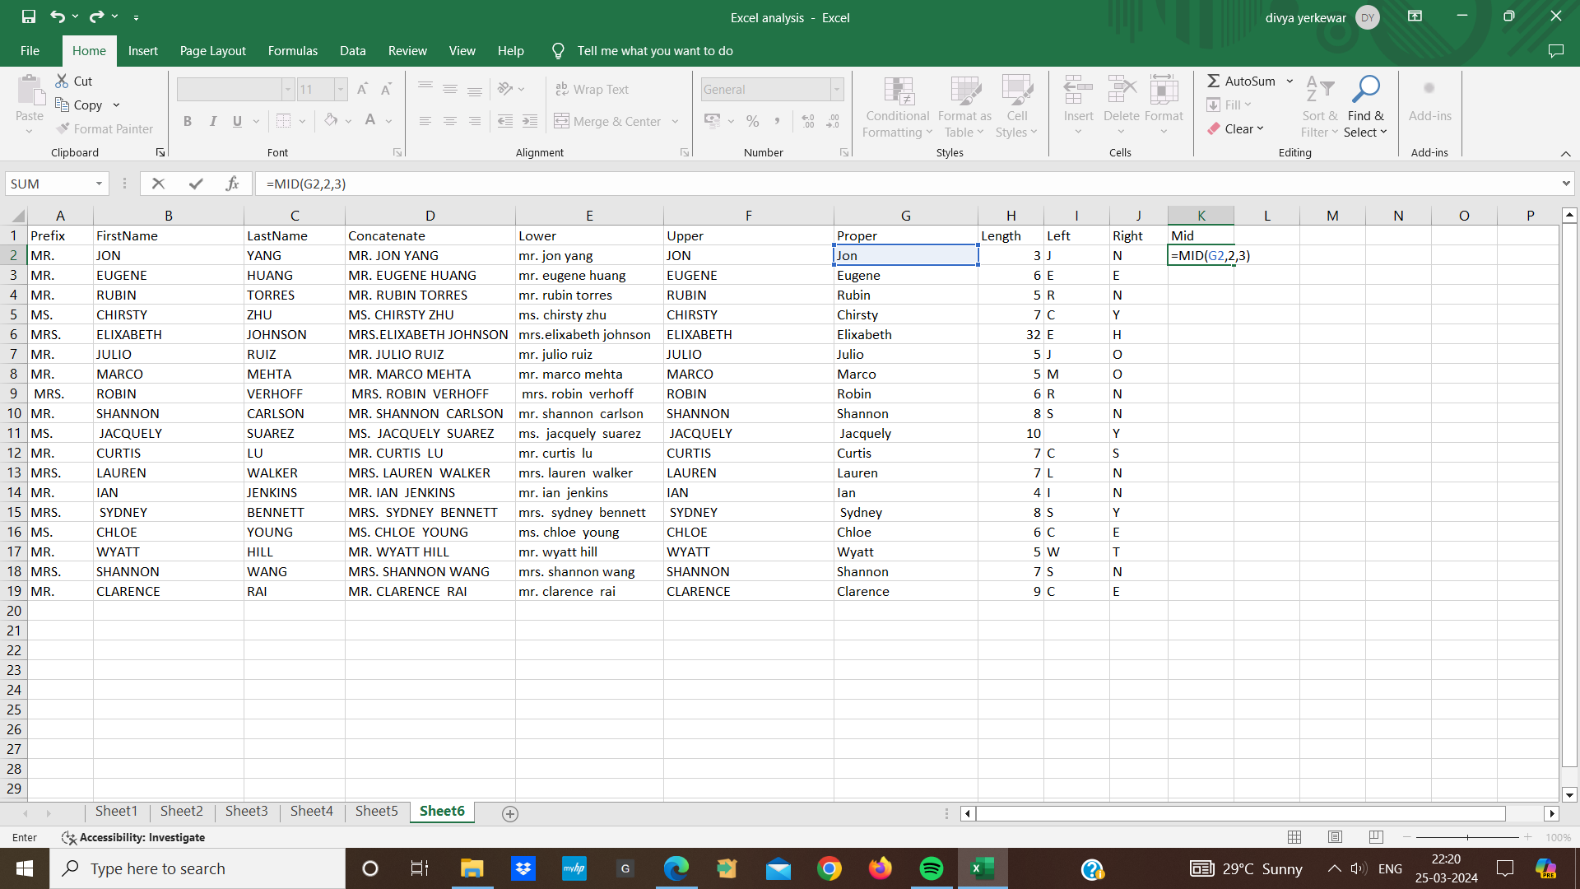

**9.find function:**

* Function function is used to find the position of a specific character within a text string
* We choose the cell where we want the position of the found text to be displayed
* Type the find function (=FIND())into the cell
* we can enter a cell that contains the text we want to fill and the larger text in which we want to search put a comma between the two parameters and then adding a close parenthesis
* press enter cell will display the position of the found text within the larger text

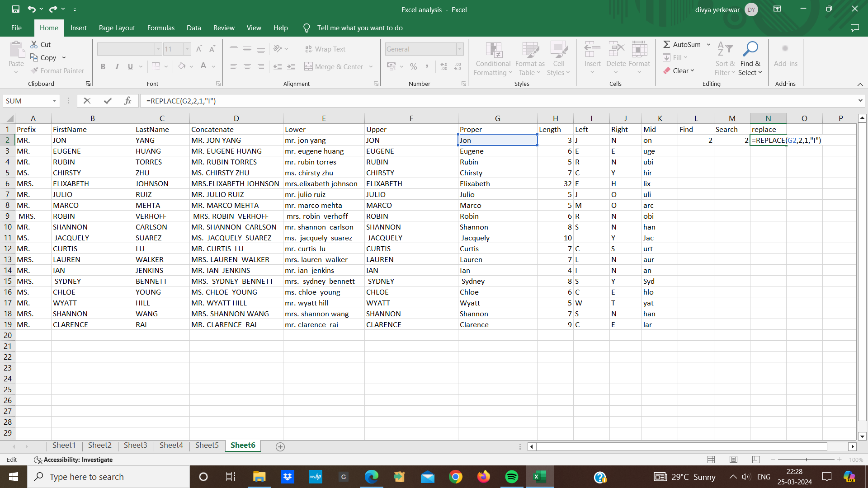

**10.Search function:**

* Search function is similar to the find function it is used to find the position of a specific character within a text string and it returns the starting position of he first occurence of the text
* Choose the cell where we want the position of the found text to be displayed
* Type the search function(=SEARCH()) into the cell
* specify the the text to find or enter a reference of cell that contain the text
* close the function and press enter the cell will display the position of the found text within the text

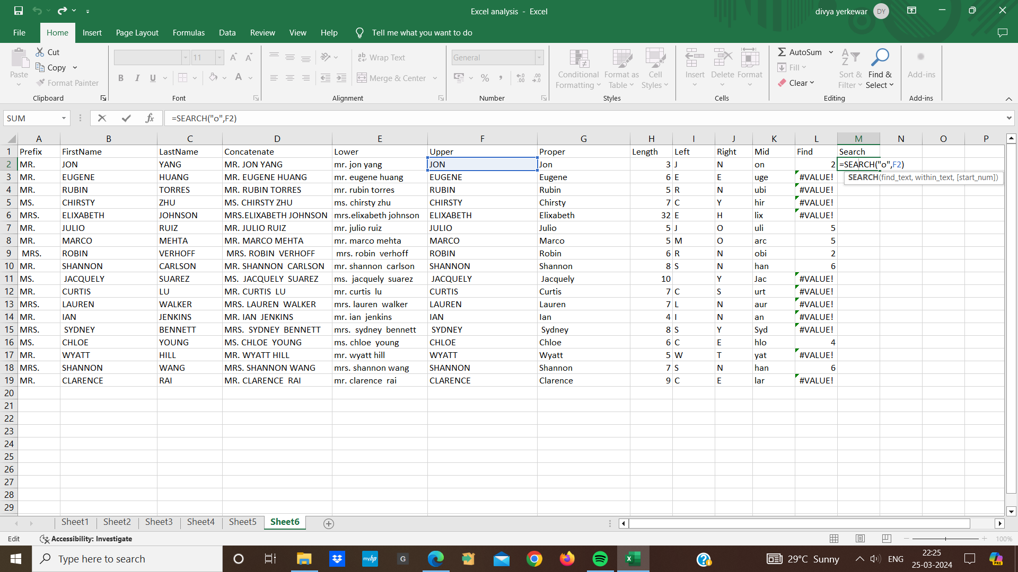

**11.Replace function:**

* Replace function allows us to replace a specific number of character in a text
* Choose the cell where we want the modified text
* Type the replace function (=REPLACE()) into the cell
* We can enter a cell that contain the original extract and starting position within the original text where we want to begin replacing character
* the number of character we want to replace
* Then the new text that we want to replace the old text
* close the parenthesis and press enter the cell will display the modified text



**12.Substitute Function:**

* Substitute function is used to replace occurence of a text within a string
* Choose the cell where we want the modified text
* Type the substitute function(=SUBSTITUTE()) into the cell
* After the open parenthesis we can enter a cell that contain the original text
* Then the old substring that we want to replace within the original text
* the new substring that we want to replace the old substring with
* Close the function and press enter and the cell will display the modified text string

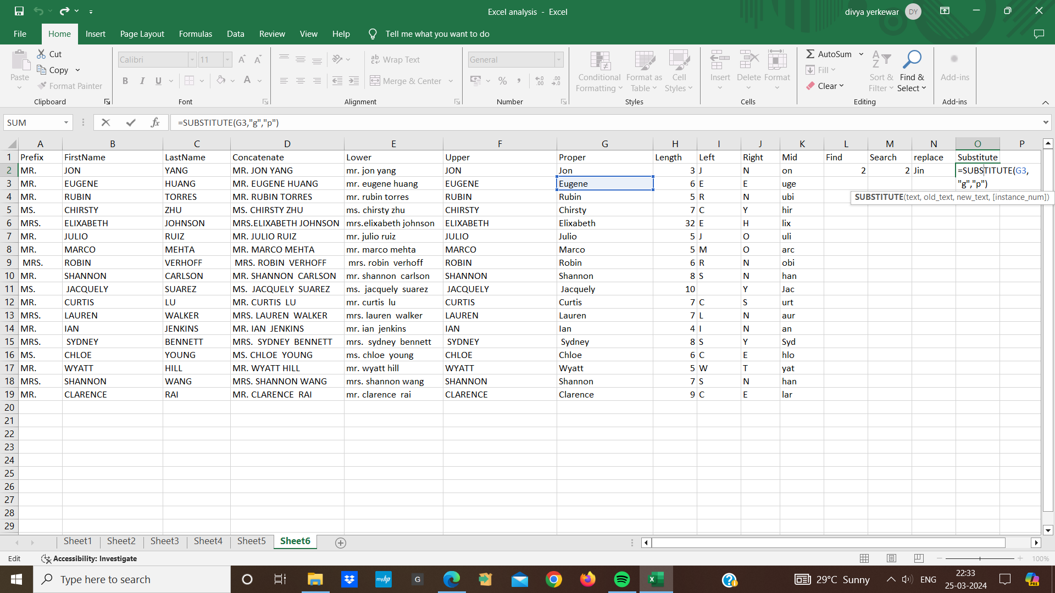

* **IF, AND, and OR Functions:**

1. **IF:**

* IF function is used to check if a condition is true or false and then perform different actions based on result
* Basic syntax is =IF(condition,value if true , value if false)
* condition means what you want to check this could be anything from whether one number is bigger than another
* value if true means what should happen if the condition is true
* value if false means what should happen if the condition is false

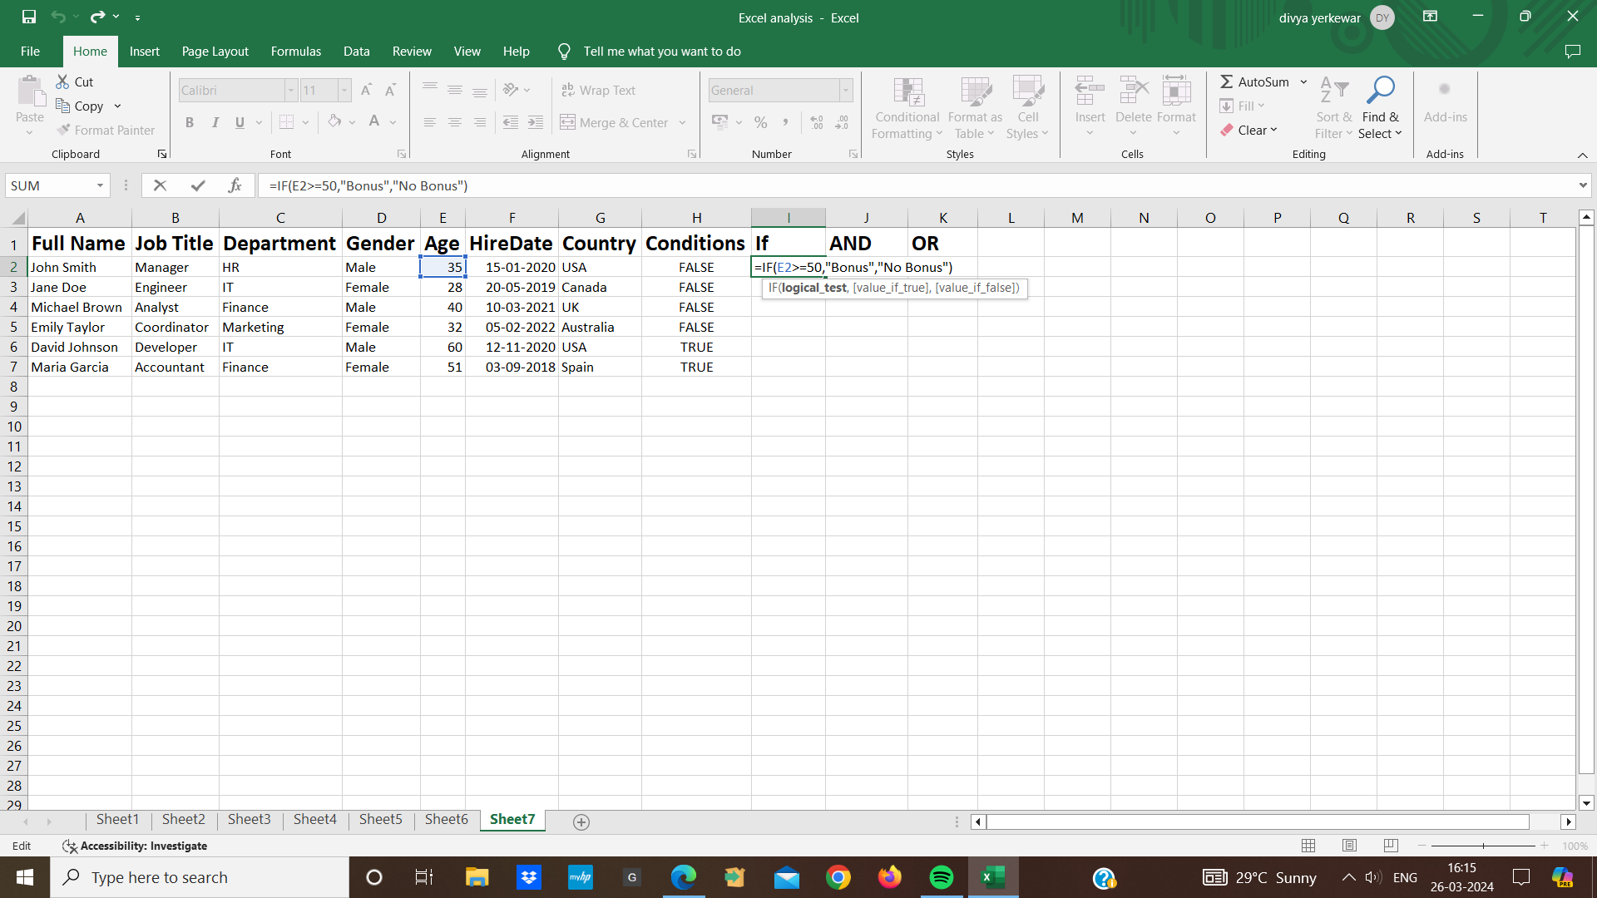

1. **AND:**

* The AND function is used to determine if multiple conditions are true . if all conditions are true .AND return included if any conditions is false AND return excluded.
* Basic syntax is =IF(AND(condition,value if true , value if false)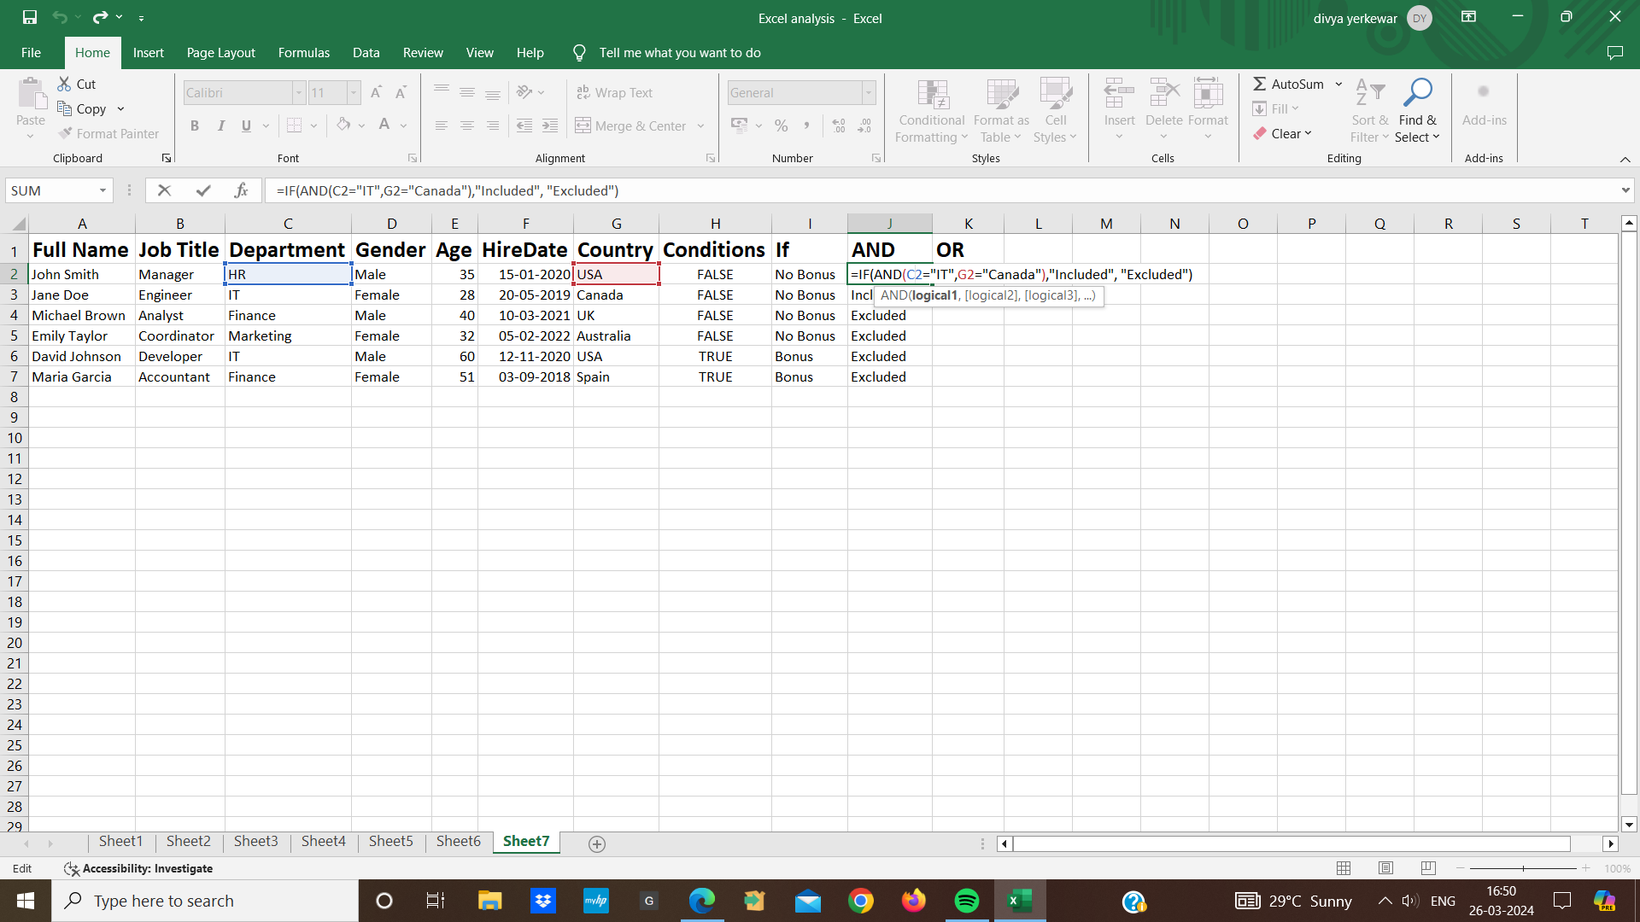

1. **OR:**

* The OR function in excel is used to check if any of the given condition are true if atleast one condition is true , OR returns Included if all conditions are false ,OR returns excluded
* Basic syntax is =IF(AND(logical condition1,logical condition2,logical condition3, value if true , value if false)

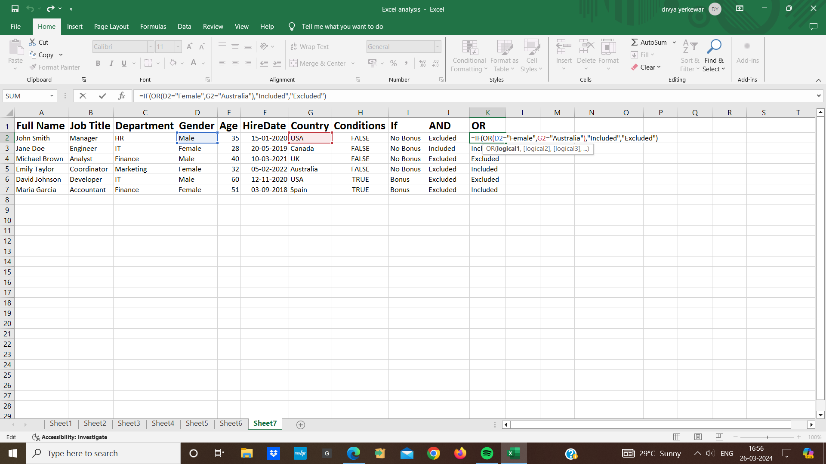

* **TODAY():**
* Today() is used to get the current date. it automatically updates everytime the worksheet is opened
* To use the today function we just need to type it into a cell ( =TODAY()) and press enter excel will display the current date in that cell
* **NOW():**
* NOW() is used to get the current date and time
* To use the now function we type (=NOW()) into a cell and press enter and excel will display the current date and time in that cell
* **DAY():**
* DAY() is extracts the day part from a specified date
* we type (=DAY(date) where date is a date or a cell containing a date
* And excel will display the day
* **MONTH():**
* MONTH() extracts the month part from a specified date
* we type (=MONTH(date)) where date is date or a cell containing a date
* **YEAR():**
* YEAR() extracts the year part from a specified date
* we type (=YEAR(date)) where date is date or a cell containing a date
* **HOUR():**
* HOUR() extracts the hour part from a specified a time value
* We type (=HOUR(time)) where time is a time or cell containing a time value
* And excel will display the hour
* **MINUTE():**
* MINUTE() extracts the minute part from a specified a time value
* We type (=MINUTE(time)) where time is a time or cell containing a time value
* And excel will display the minute
* **SECOND():**
* SECOND() extracts the second part from a specified a time value
* We type (=SECOND(time)) where time is a time or cell containing a time value
* And press enter excel will display the second
* **date+3 days():**
* We can add specific number of days to a date by simply using the addition operator with the number of days we want to add
* If we have a date in cell A2 and we want to add 3 days to that date them we would write the formula as A2+3
* **date+3 months():**
* We can add a specific number of months to date using EDATE function
* The EDATE function adds a specified number of months to a date
* Syntax is (=EDATE(start date,months)
* If we have a date in cell A2 and we want to add 3 months to that date we would write formula as =EDATE(A2,3)
* **date+3 year():**
* we can add a specific number of year to date since EDATE adds months not year we need to multiply the number by 12 to get the evaluate number of months
* Syntax is =EDATE(A2,3*12)
* In this formula the date is in cell A2 and adds 3 year to it by multiplying years to 12 months

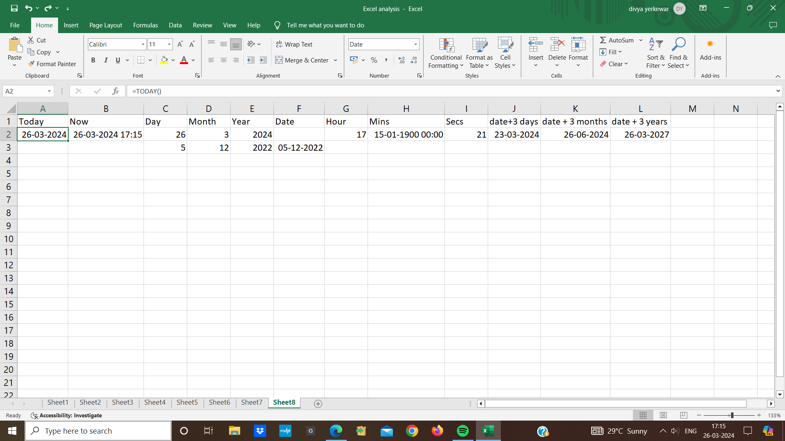

* **Data Validation:**
* Data validation allows us to control what type of data can be entered into a cell means it helps us to ensure that the data entered meets certain criteria
* Here we can control data type we can specify whether the cell should contain a number ,text,time,date
* We can set minimum and maximum values for numeric entries specify range of date
* We can set length of text
* To apply data validation to a cell first we select the cell where we want to apply data validation
* Then go to “Data” tab and click on Data validation in the data tools
* In the data validation box choose the type of validation we want to apply
* For e.g list,date,time, text length

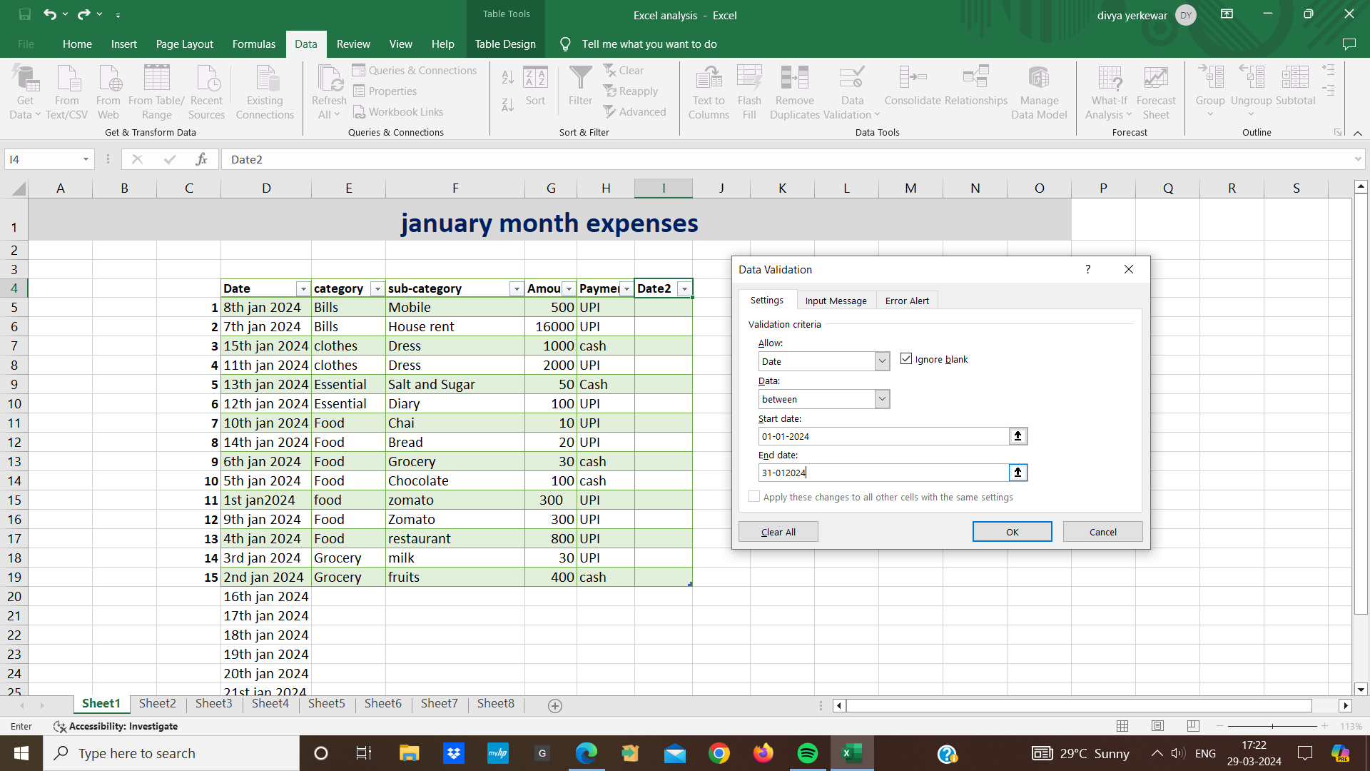

* Set the criteria and click ok to apply the validation rules
* Once the data validation is applied we will only be able to enter data that meets the specified criteria
* If i tried to enter invalid data excel will display an error message.

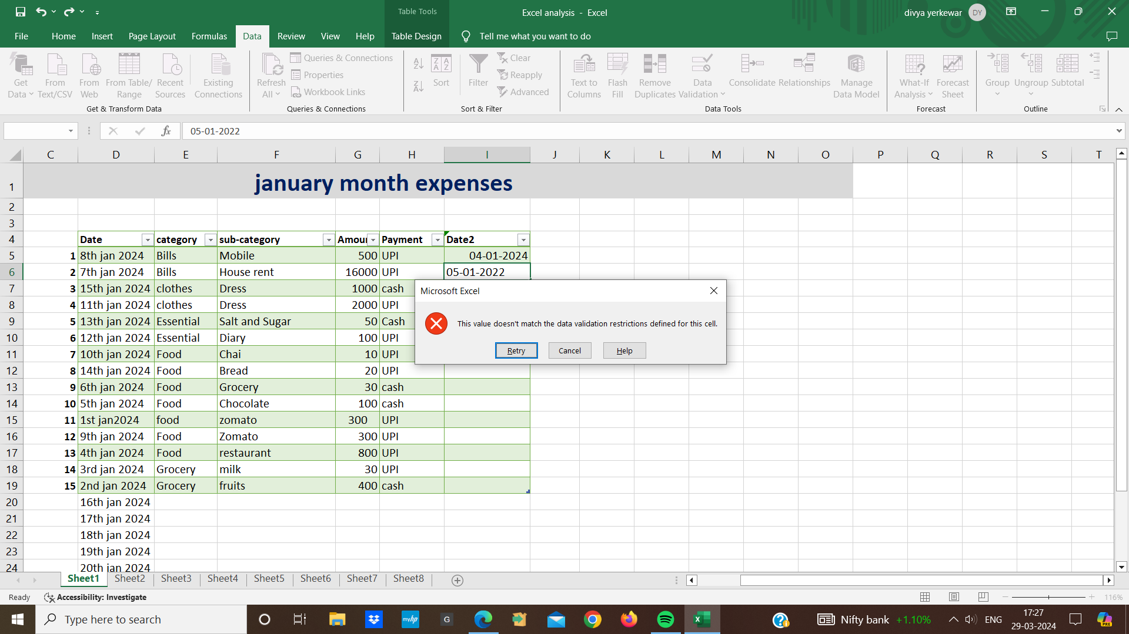

* **VLOOKUP(VERTICAL LOOKUP):**
* VLOOKUP is like searching for information in a table it stands for vertical lookup
* If we have a table with two or more columns like a emp id, employee name, department and salary
* We want to find a salary based on their emp id
* We use VLOOKUP Syntax is (=VLOOKUP(lookupvalue,table array,col index num, range lookup)
* Lookup value means the value we are looking for
* Table array means the range of cells containing our data
* The column number in the table where we want it return for eg salary column
* Rangelookup means true for an approximate match , false for an exact match

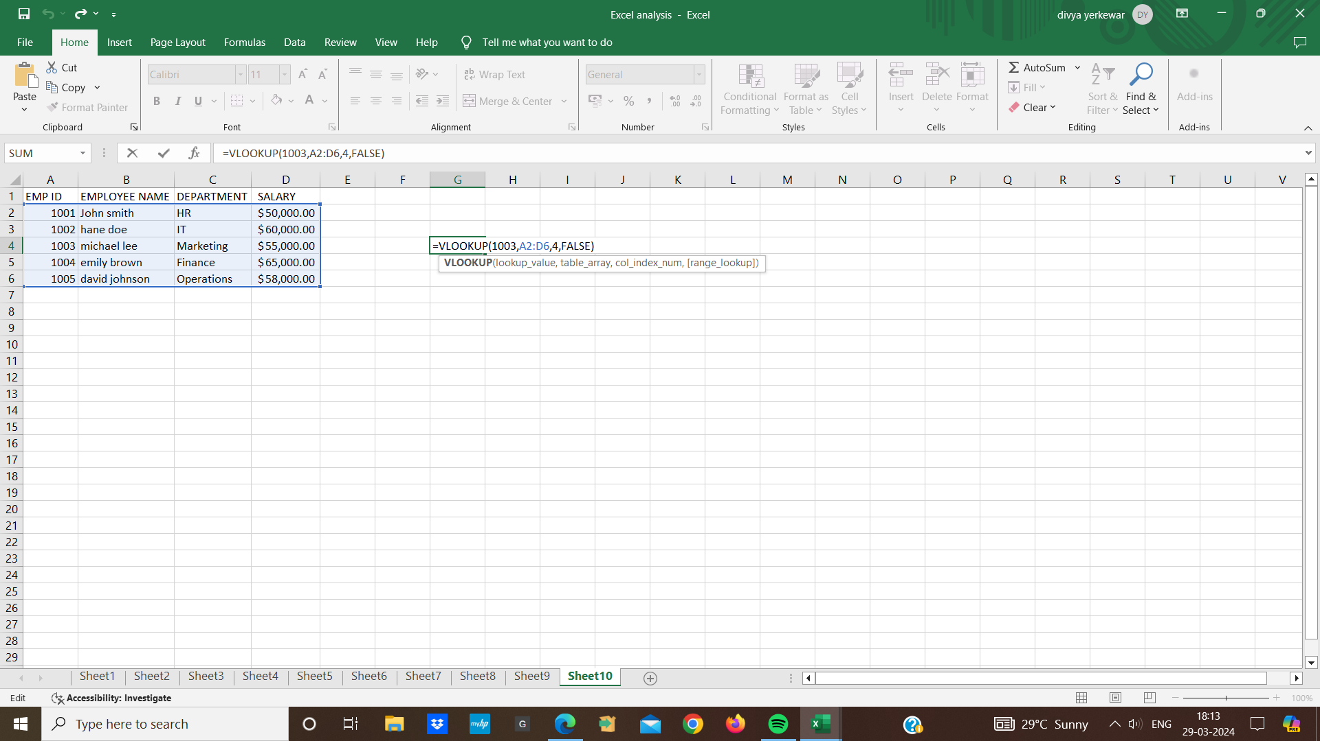

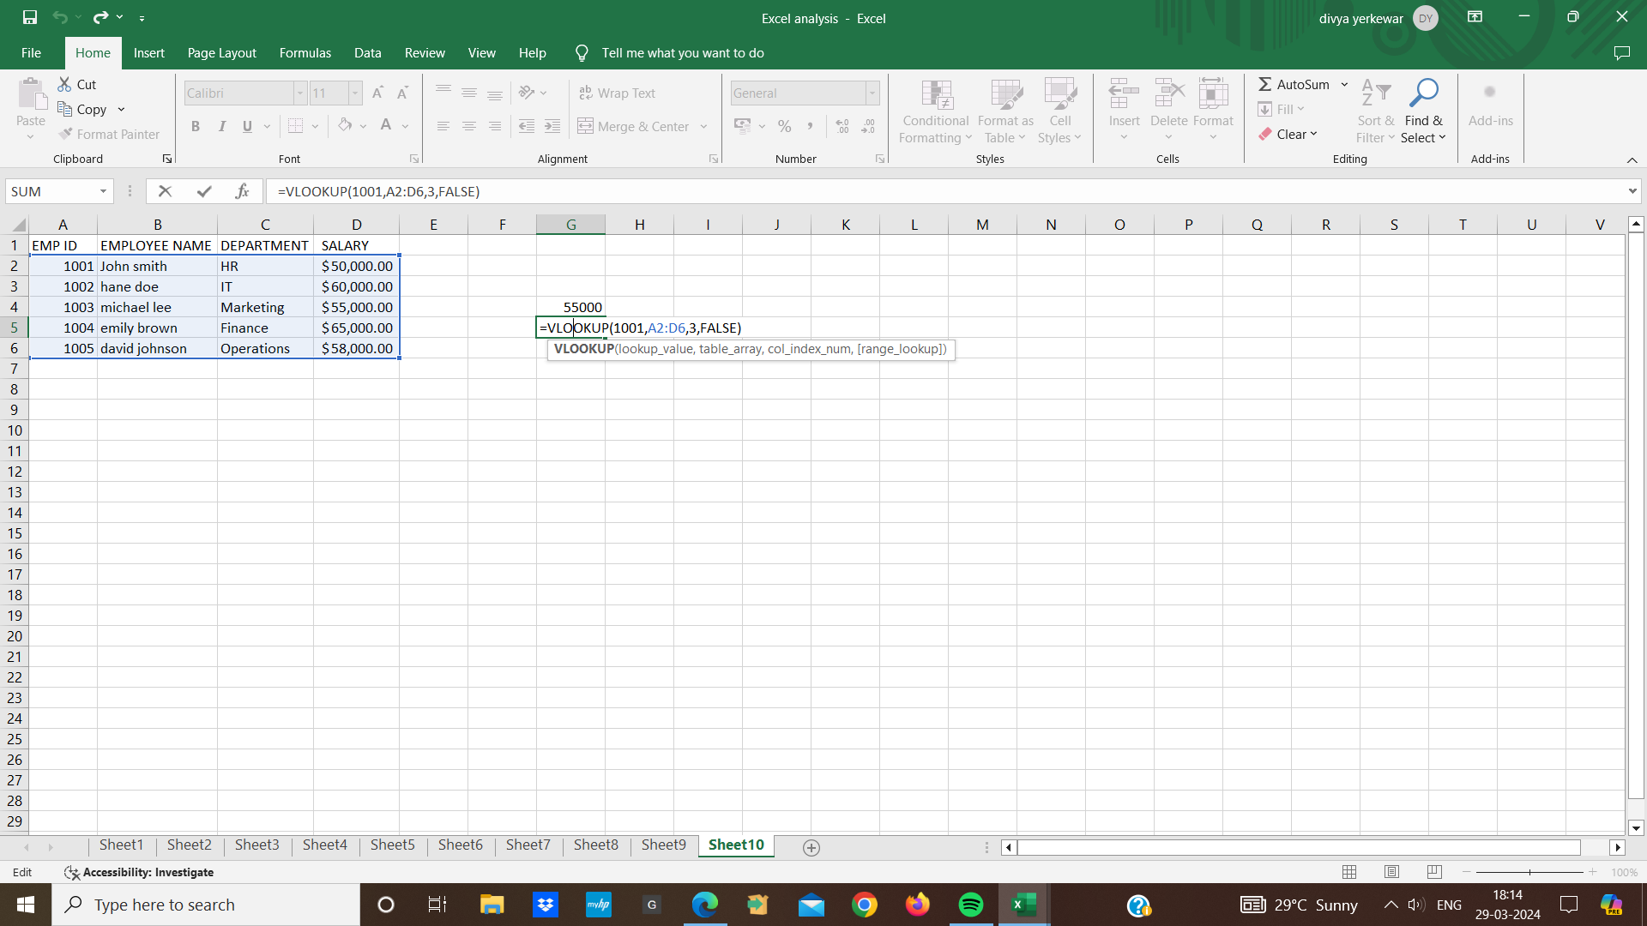

* **MATCH Function:**
* The MATCH function is used to find the position of a specified value within a range of cell
* Syntax is (=MATCH(lookup value, lookup array, (match type))
* lookup value means the value we want to find in the lookup array
* The lookup array means the range of cell where we want to search for the lookup value
* Match type means if i specified 1 means they finds the largest value less than or equal to the lookup and if i specified 0 the finds the first exact match
* For ex we have a list of emp id, employee name, department and salary
* We want to find the position of salary 58,000
* Then the formula is =MATCH (D6,D2:D6,0)
* Means D6 is a cell that containing a value and the range is D2:D6 and 0 means where it finds an exact match

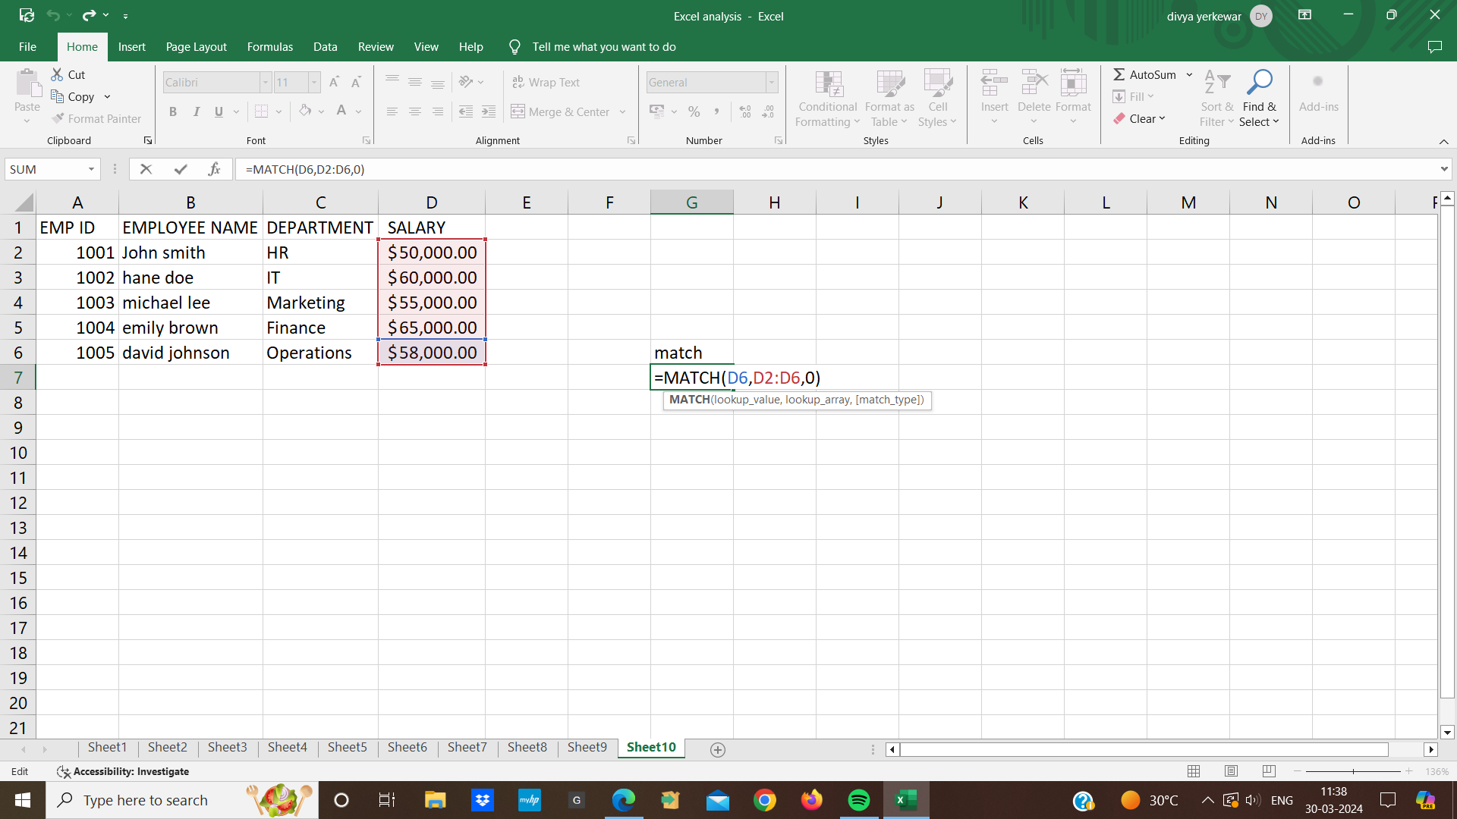

* **INDEX Function:**
* INDEX function is used to retrieve a value from within a table
* First we select the cell where we want the value
* Then write a formula (=INDEX(array,row num,(column num))
* Array means in array we specify the range of cell
* row num means in specify the row number
* specify the column num and press enter the result will be displayed in the selected cell

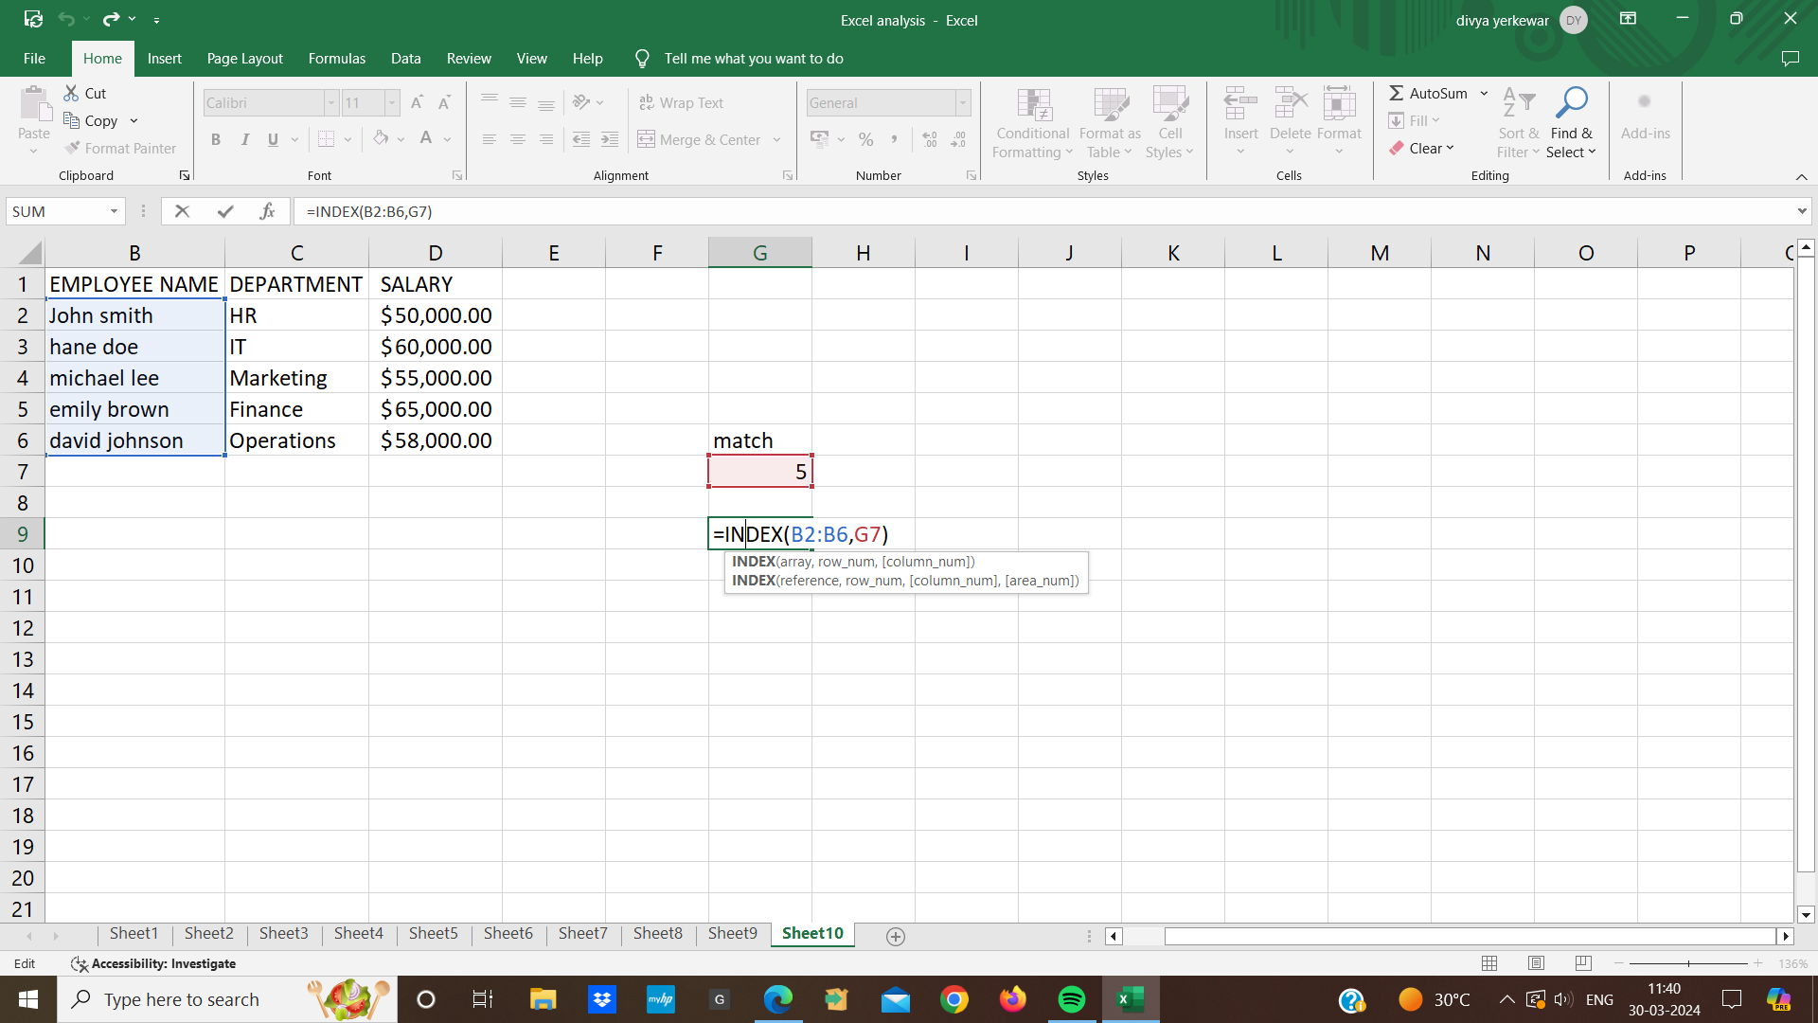

* In this example we combined index function with match function to retrieve a specific value from a range
* MATCH function : MATCH(D6,D2:D6,0) searches for the value in cell D6 within a range D2:D6 lookup array and the third argument is 0 specified that an exact match should be found
* INDEX function: Index function then takes the result from match function and uses it to retrieve a value from the range B2:B6 The range B2:B6 contains the value we want to retrieve

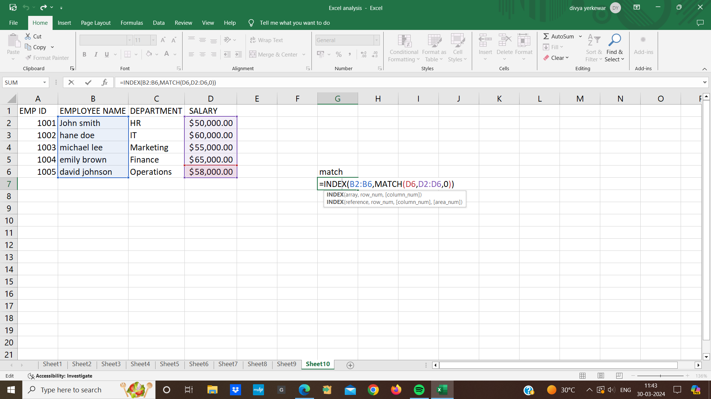

* **HLOOKUP Function:**
* HLOOKUP is similar to the VLOOKUP but it searches for a value in the first row of a table and return a value in the same column from a specified row
* We provide a key and it looks it up in the top row and return the value from a specified row below
* first we select the cell and write the formula (=HLOOKUP(lookup value,table array, row index num, (range lookup))
* for ex we have a table where row 1 contain emp id ,row 2 contain first name , row 3 contain job and row 4 contain salary
* If we want to find the salary of a person with id 104 we can use HLOOKUP

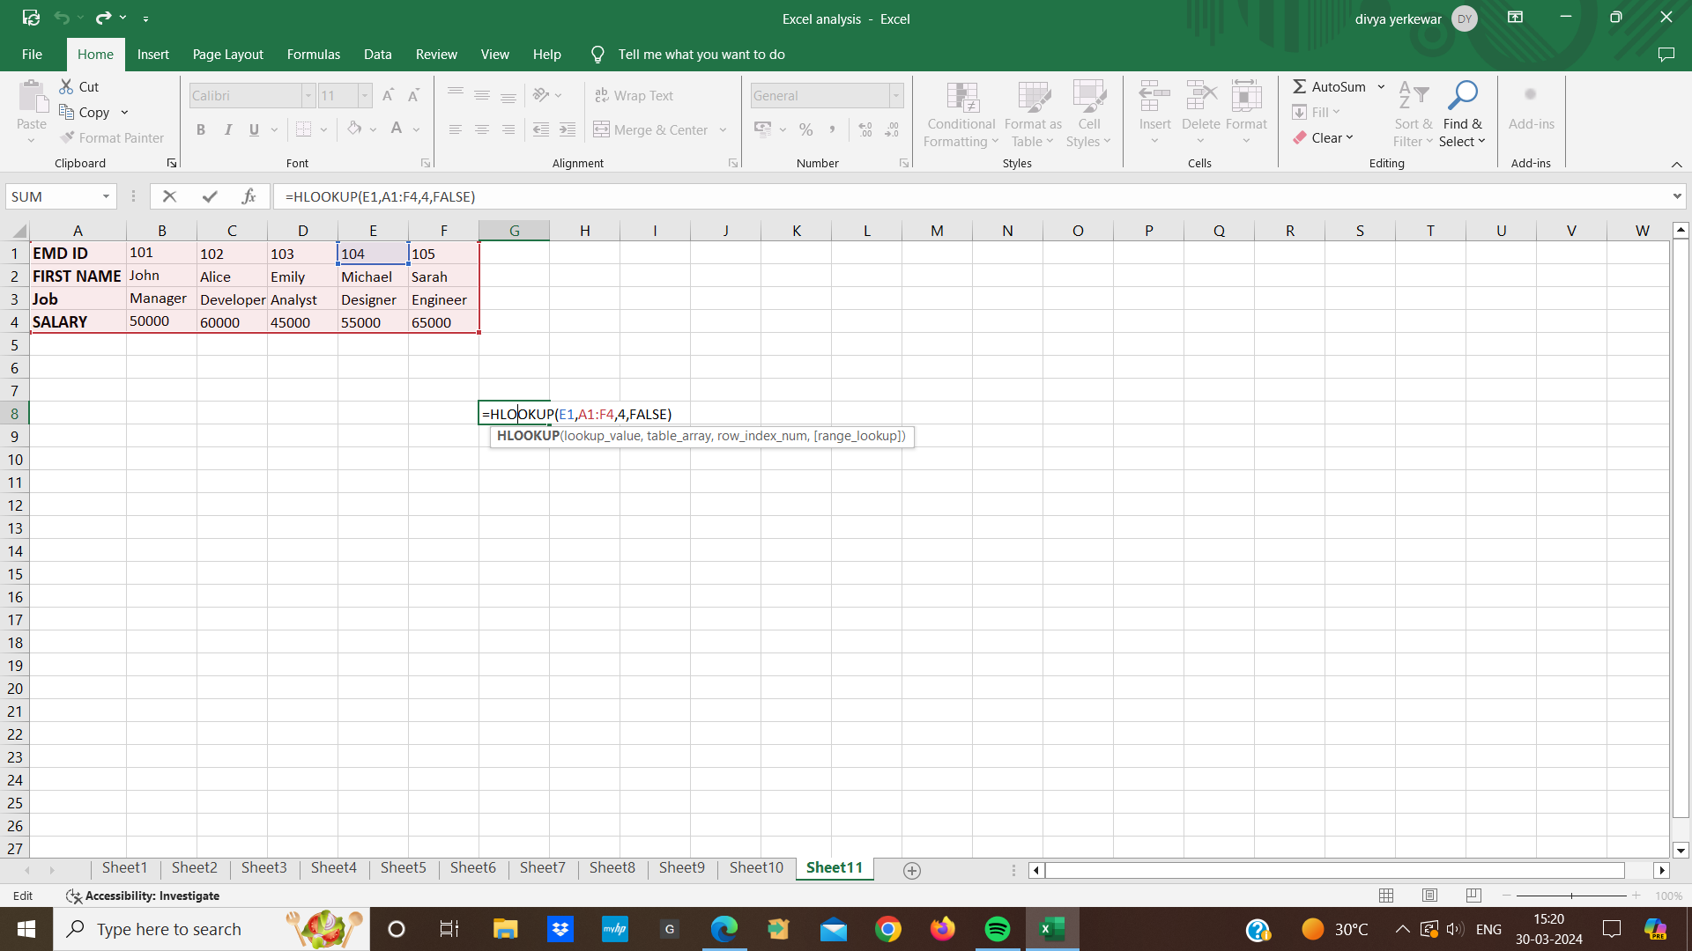

* **LOOKUP Function:**
* LOOKUP function is used to find a value within a one row or one column and return the corresponding value from another row or column
* Syntax is (=lOOKUP(lookup value, lookup vector,result vector))

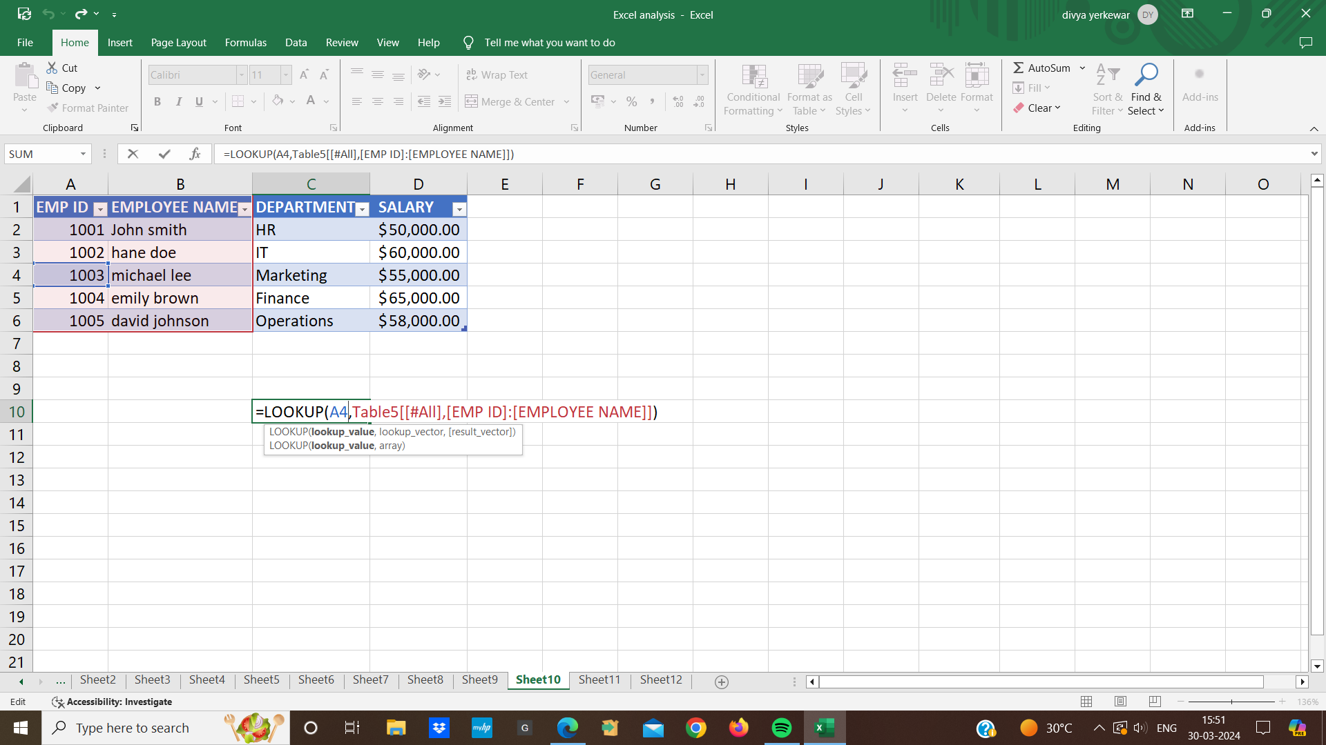

* **Macros:**
* A macros is a set of recorded actions that we can run to automate repetitive task
* First we go to the view tab and click on the macros and select “Record macro”
* Name our record and choose where to store and click on the “ok” to start recording
* select the range of cell containing amount
* Go to the home tab and click on the “conditional formatting” and choose ‘highlight cells rules”<greater than
* enter value “ 1000” as the value and click “ok” to apply the formatting and stop the recording the macro

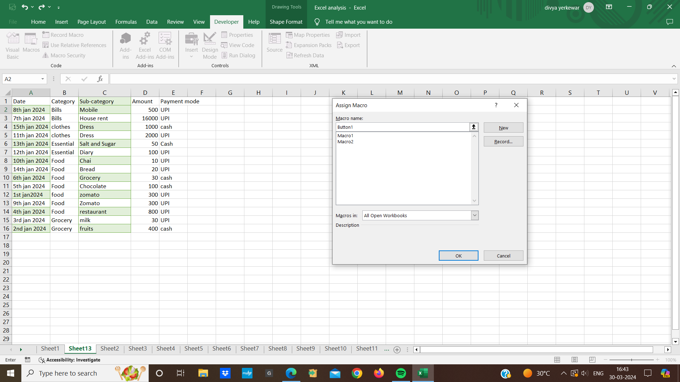

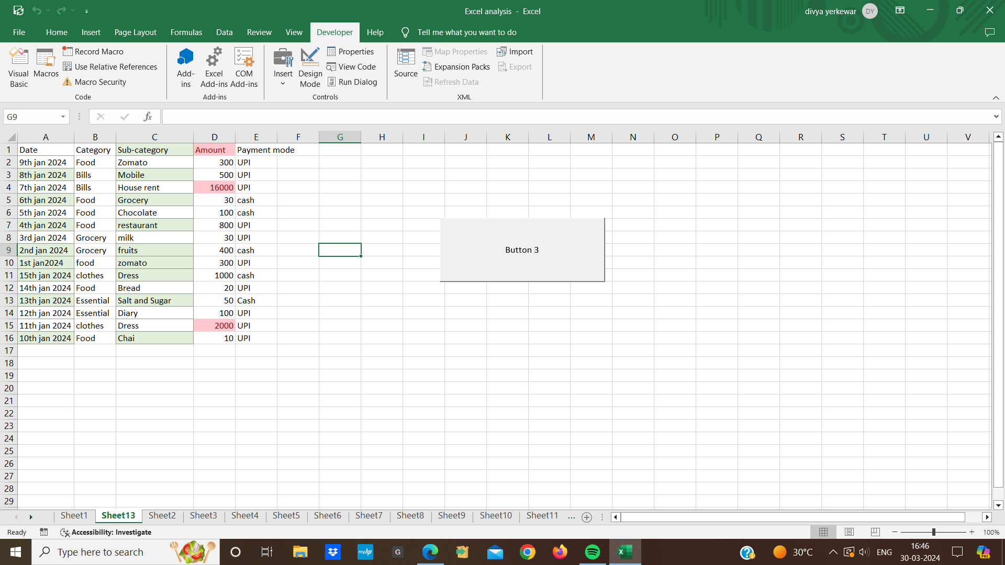

* **Pivot Table:**
* A pivot table is a tool to analyze data quickly by organizing it into a structured format
* we prepare data first we ensure that our data is organized in a tabular format and then select our data and go to the “insert” tab on the excel ribbon
* Click on the “pivot table” and excel will automatically detect the range of cell we selected
* In the pivot table field pane that appears on the right,drag and drop the field we want to analyze into the rows , column ,values or filter areas
* for ex we can drag a field like “category” and “date” into the roes and then drag the max of amount into the values area to see the amount

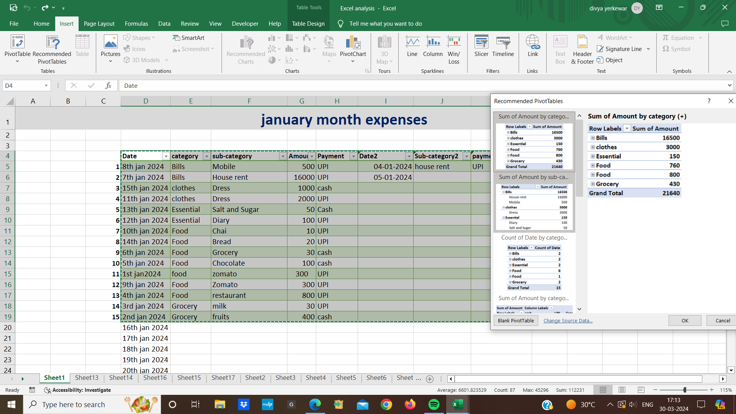

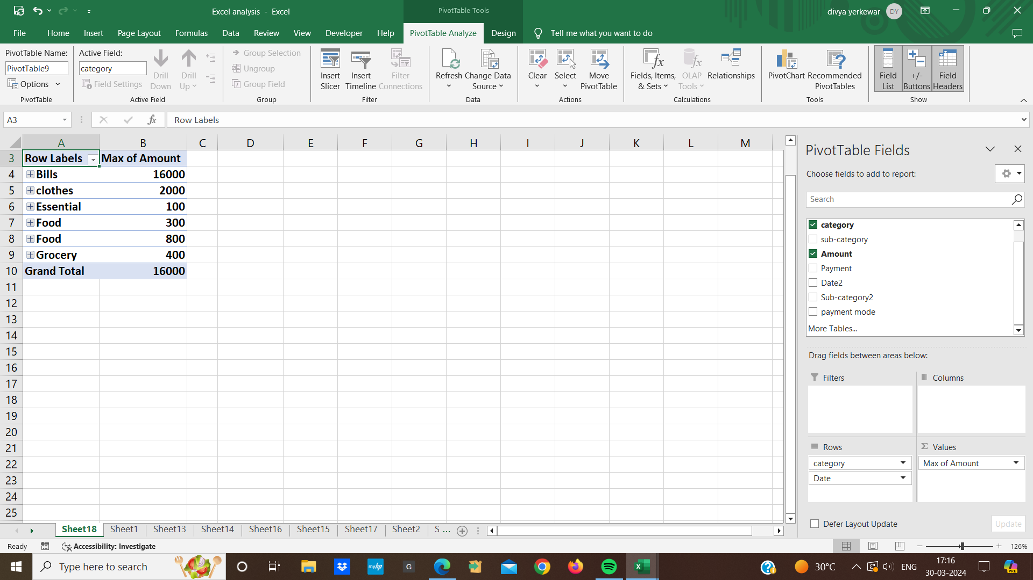

* Once we have created our pivot table we can easily create charts and graphs
* first we click anywhere inside our pivot table to select it and go to the “insert” tab and click on the desired chart type in the chart group e.g column,line,pie
* excel will automatically generate a chart based on our pivot table data
* we can customize the chart further by adding titles,adjusting the axis labels ,changing colors

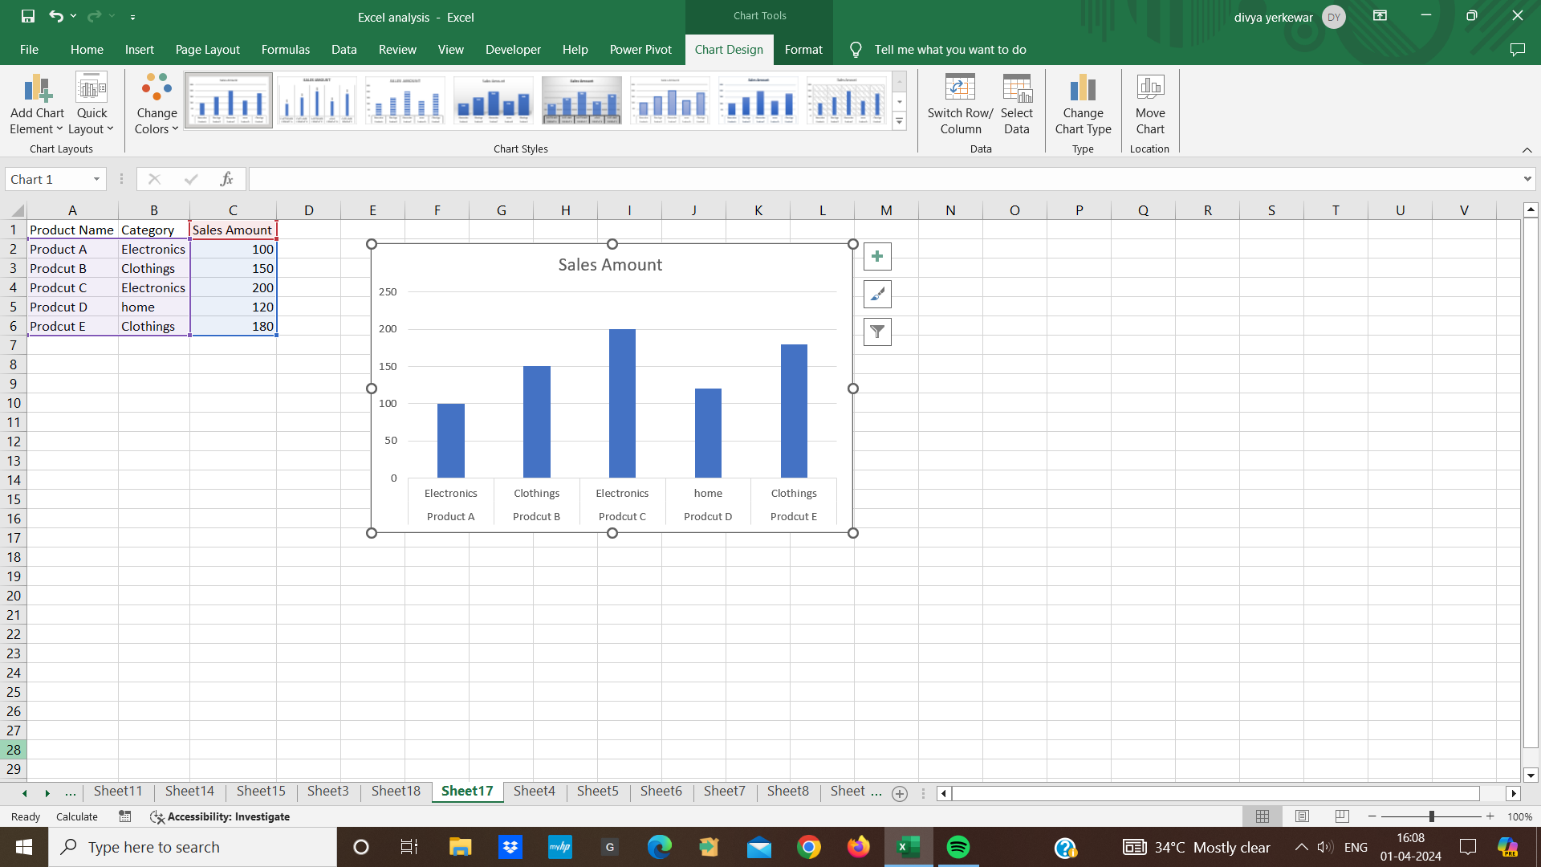

* **slicer:**
* A slicer is a filtering tool that provides a user friendly way to filter data in pivot table, pivot charts and excel tables
* It allows us to select one or more items from a list and data is instantly filtered based on the selections
* Insert a slicer from the insert tab choose the fields we want to filter and the slicer will appear dropdown menus on our worksheet

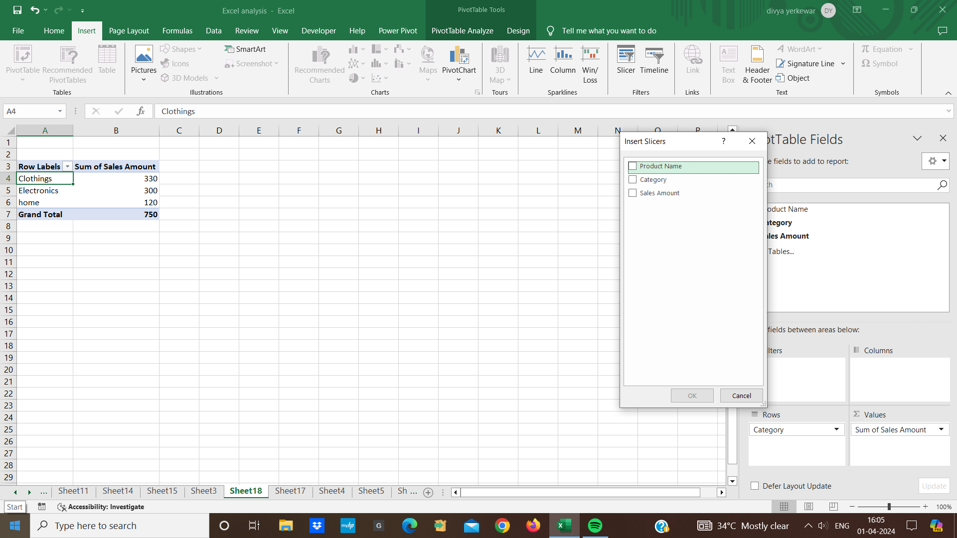

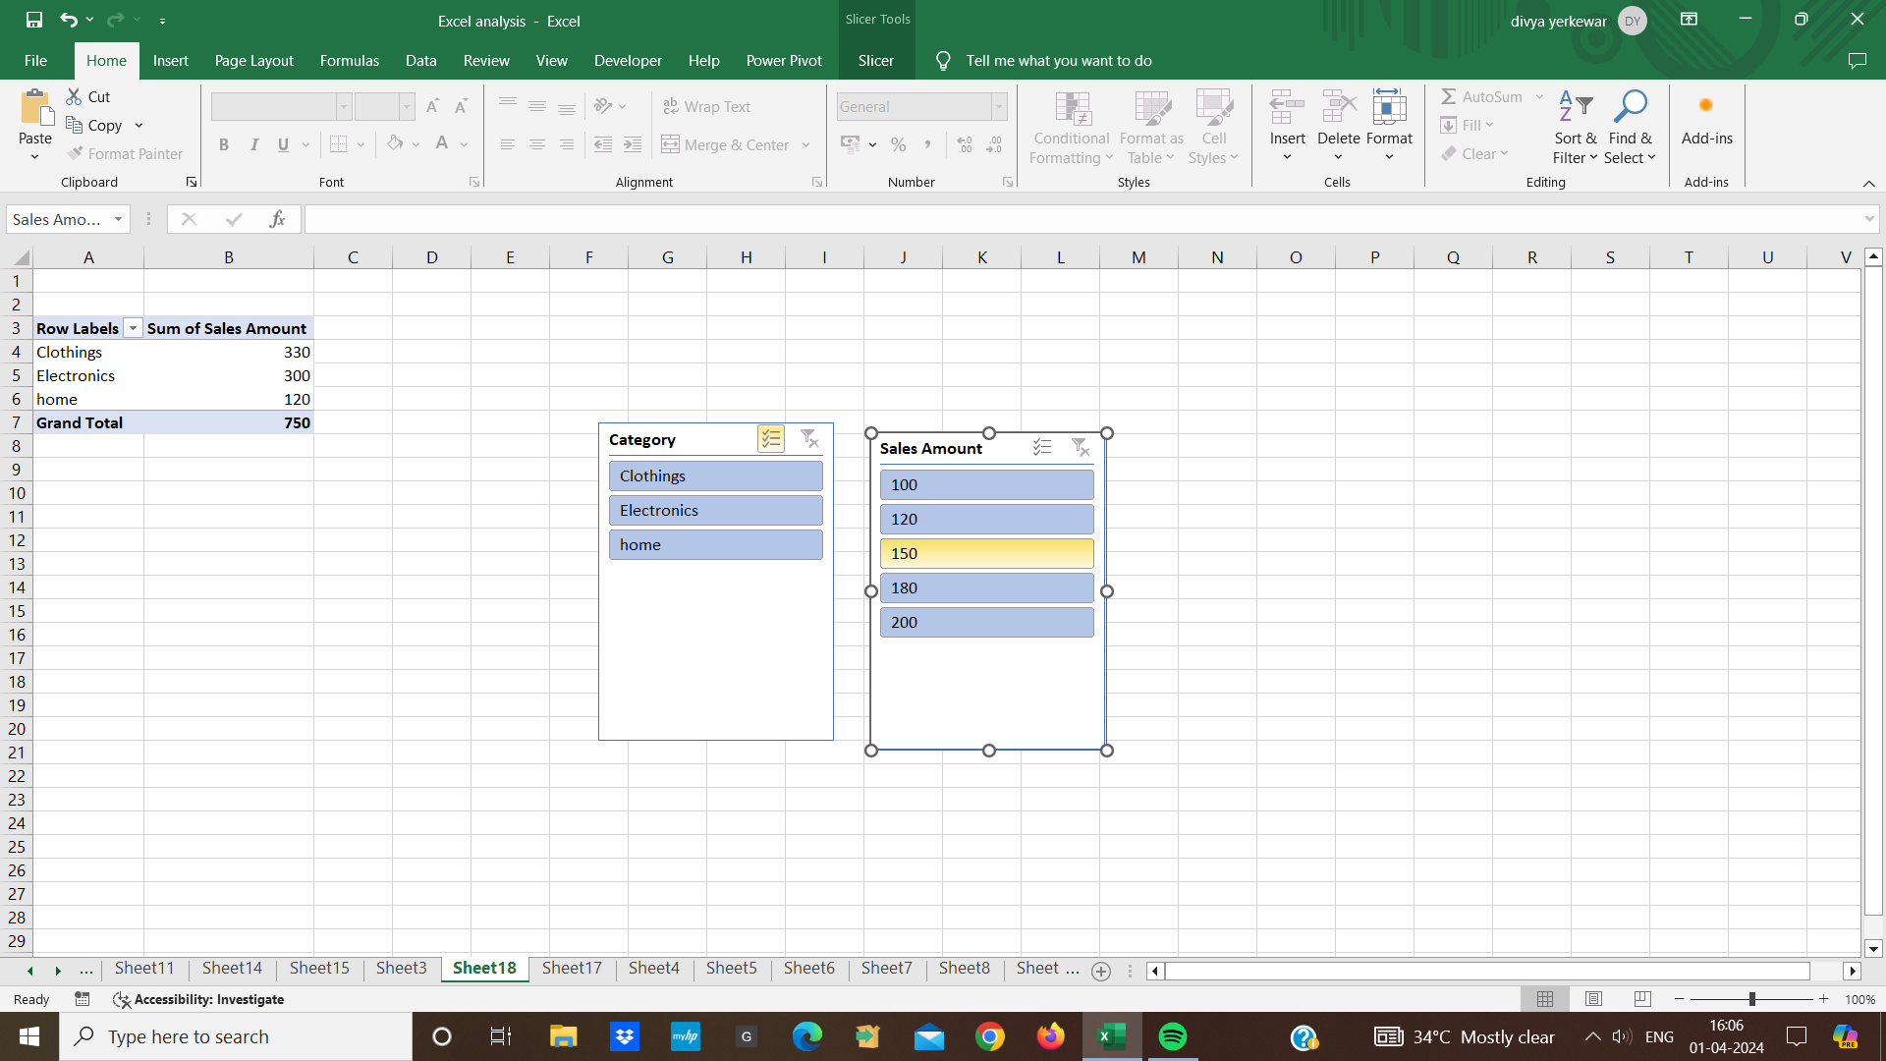

* **Power Pivot:**
* Power pivot allows us to analyze large volumes of data from various sources.
* And create relationship between tables use data analysis expression for calculation and create reports
* To enable powerpivot add in we go to “file” tab in excel and click on options and then “Add-Ins” then select “COM Add-ins” from the manage drop-down menu and click “go”
* check the box power pivot and click ok

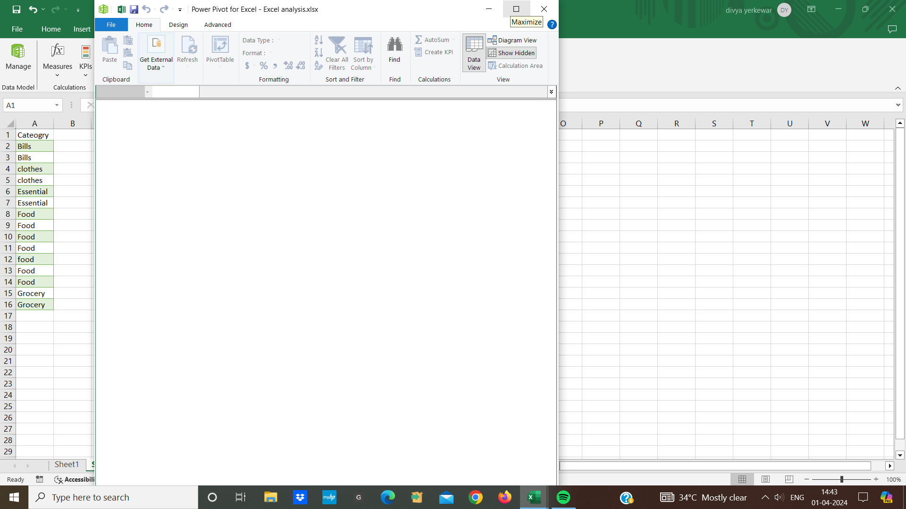

* Then we go to the power pivot tab and click on “manage” click on the “from other sources” to import from databases,excel files,text files,etc

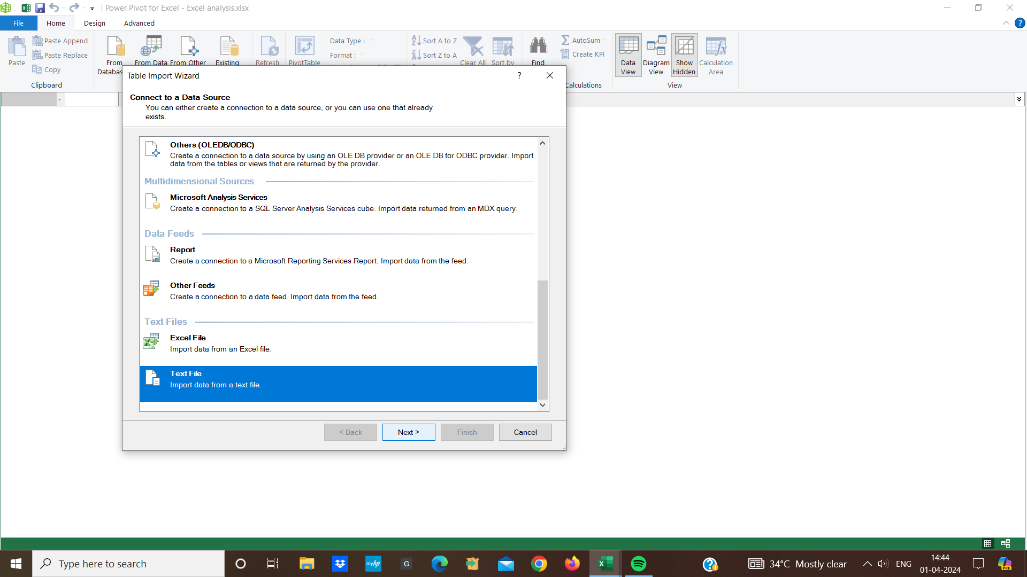

* In the power pivot window click on the “Diagram view” button to switch the diagram view
* Also we can create pivot tables and charts to create reports and visualizations